

P r o p o s e d R e d i s t r i b u t i o n o f
t h e A C T i n t o E l e c t o r a t e s f o r t h e L e g i s l a t i v e A s s e m b l y

A C T L e g i s l a t i v e A s s e m b l y

E l e c t o r a l B o u n d a r i e s

R e d i s t r i b u t i o n 2 0 11





Proposed Redistribution of
the ACT into Electorate' s for the Legislative Assembly

ACT Legislative Assembly
I

Electoral Boundaries

Redistribution 2011
I
I



REDISTRIBUTION COMMITIEE


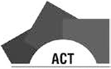

ACCESSIBILITY

Elections ACT is committed to making its information and services accessible to as many people as possible.
• If you have difficulty reading a standard printed document and would like to receive this publication in an alternative format – such as large print or audio – please telephone
6205 0033.
• If English is not your first language and you require the translating and interpreting service – please telephone 13 14 50.
• If you are deaf or have a hearing impairment or speech impairment, contact us through the National Relay Service:
Ø TTY users phone 133 677 then ask for 02 6205 0033
Ø Speak and Listen users phone 1300 555 727 then ask for 02 6205 0033
Ø Internet relay users connect to NRS (www.relayservice.com.au) and then ask for
02 6205 0033
• ACT Interpreter Service – for the deaf and blind – please telephone 6287 4391.

ISBN: 978 0 642 60554 2

© Australian Capital Territory, Canberra 2011

This work is copyright. Apart from any use as permitted under the Copyright Act 1968, no part may be reproduced by any process without written permission from the ACT Electoral Commission, except that permission is given for use and reproduction of the statistics included in this publication.

Produced by the ACT Electoral Commission
PO Box 272, Civic Square ACT 2608. Email: elections@act.gov.au
Phone: (02) 6205 0033

ACT Electoral Commission homepage: http://www.elections.act.gov.au Publication Number: 11/0561
ACT Government homepage:

http://www.act.gov.au

Phone: Canberra 13ACT1 or 132 281

ACT Legislative Assembly Electoral Boundaries
Redistribution 2011

Table of Contents

Summary of proposed redistribution.................................................................... 1
Overall statistical summary ................................................................................... 2
Quotas and maximum and minimum numbers of electors ................................................... 2
Existing electorates: Statistical summary ............................................................................... 2
Proposed electorates: Statistical summary............................................................................ 2
Map of proposed boundaries ................................................................................. 3
Legal Requirements ............................................................................................... 4
Commencement of the redistribution process ..................................................................... 4
The Redistribution Committee ............................................................................................. 4
Invitation to submit suggestions and comments.................................................................... 4
Redistribution criteria ............................................................................................................ 4
Objections ............................................................................................................................. 5
Numbers of electors .............................................................................................. 6
Numbers of electors immediately after the redistribution ................................................... 6
Numbers of electors at the time of the next general election.............................................. 6
Quotas ................................................................................................................................... 7
The other redistribution criteria ........................................................................................... 8
Suggestions and comments ................................................................................... 9
Brief summary of suggestions ................................................................................................ 9
Brief summary of comments ............................................................................................... 11
The Committee’s proposed boundaries ............................................................. 12
Retaining the current boundaries unchanged ...................................................................... 12
The Brindabella-Molonglo boundary ................................................................................... 12
The Ginninderra-Molonglo boundary.................................................................................. 14
Inclusion of the district of Molonglo Valley in one electorate ............................................. 20
Changes to the number of Members to be elected in each electorate .............................. 20
Conclusion................................................................................................................. 21
Names of electorates........................................................................................... 22
Appendix A: Constitution of Proposed Electorates ........................................... 23
Proposed Electorate of Brindabella..................................................................................... 23
Proposed Electorate of Ginninderra ................................................................................... 24
Proposed Electorate of Molonglo ....................................................................................... 25
Appendix B: Copies of public suggestions........................................................... 27

Redistribution Committee for the Australian Capital Territory
Phillip Green — Neil Savery — Bill Hirst — Stephen Collett

Summary of proposed redistribution

The 2011 ACT Redistribution Committee proposes in accordance with section 43 of the Electoral Act 1992 that the current electoral boundaries in the Australian Capital Territory be altered as follows:

• The suburbs of Palmerston and Crace be transferred from Molonglo to
Ginninderra;

• The portion of the district of Gungahlin bounded by the suburbs of Palmerston and Crace and Barton Highway and Gungahlin Drive be transferred from Molonglo to Ginninderra; and

• The portion of the district of Molonglo Valley north of the Molonglo River be transferred from Ginninderra to Molonglo.

The proposed electorates are as follows:

BRINDABELLA, a 5-Member electorate comprising the district of Tuggeranong (excluding the suburb of Hume), the Woden Valley suburbs of Chifley, Farrer, Pearce and Torrens and the districts of Booth, Coree, Cotter River, Paddys River, Rendezvous Creek, Tennent and Mount Clear;

GINNINDERRA, a 5-Member electorate comprising the districts of Belconnen and Hall (including the entire Village of Hall) and the Gungahlin suburbs of Crace, Nicholls and Palmerston; and

MOLONGLO, a 7-Member electorate comprising the districts of Gungahlin (excluding the suburbs of Crace, Nicholls and Palmerston), Canberra Central, Molonglo Valley, Weston Creek, Woden Valley (excluding the suburbs of Chifley, Farrer, Pearce and Torrens), Jerrabomberra (including the entire suburb of Hume), Kowen, Majura, and Stromlo.

Overall statistical summary

Quotas and maximum and minimum numbers of electors

 | ACT | 5 Member electorates | 7 Member electorate
31 March 2011  Actual enrolment  Quotas  Not more than 110% of the quota  Not less than 90% of the quota | 248 147 | 72 984  80 282  65 686 | 102 178  112 395  91 961
October 2012  Projected enrolment  Quotas  Not more than 105% of the quota  Not less than 95% of the quota | 256 168 | 75 343  82 877  67 809 | 105 480  116 028  94 932

Existing electorates: Statistical summary

Proposed electorate | Number of  Members | Enrolment  March 2011 | % above or below quota  2011 | Projected enrolment October 2012 | % above or below quota  2012
Brindabella | 5 | 71 429 | -2.13% | 72 717 | -3.49%
Ginninderra | 5 | 69 978 | -4.12% | 71 098 | -5.63%
Molonglo | 7 | 106 740 | 4.46% | 112 353 | 6.52%

Proposed electorates: Statistical summary

Proposed electorate | Number of  Members | Enrolment  March 2011 | % above or below quota  2011 | Projected enrolment October 2012 | % above or below quota  2012
Brindabella | 5 | 71 429 | -2.13% | 72 717 | -3.49%
Ginninderra | 5 | 73 975 | 1.36% | 75 418 | 0.10%
Molonglo | 7 | 102 743 | 0.55% | 108 033 | 2.42%

For a detailed breakdown of these statistics see Appendix A.

Map of proposed boundaries
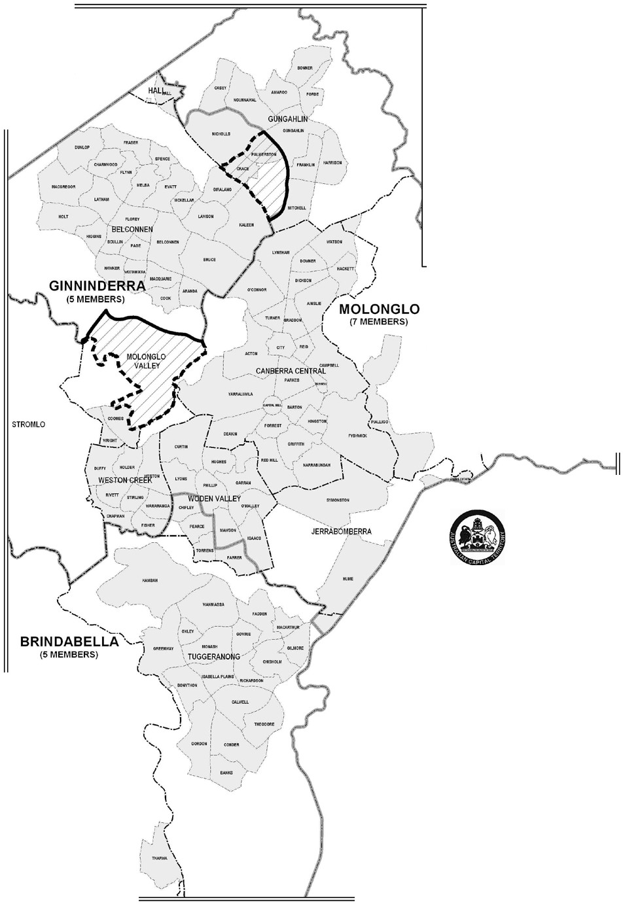

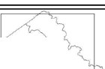

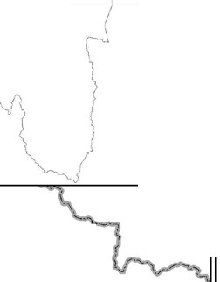

m:w
t"""" _)
j
:oat fill
WAL!S GINifiNDERRA

New South Wales

{ AUST:R

:rY

C.\PITAL {'
TERRITORY EX1'ENT Of' tAA!N w.p
I

BRINDAOELLA

sotr·u
-
w.....

MAJURA
I i i
i i i
i
i
i
i
i
i
/')i
i

KOWEN

New South Wales

PADDYS RIVER
Redistribution of the
Austrailan Capital Territory into electorates pursuant to the Electoral Act 1992

Proposed Electorates for the
ACT Legislative Assembly
of BRINDABELLA, GINNINDERRA
and MOLONGLO

Boundaries of El ectorates Division Boundaries Di strict Boundari es
Existing Boundary to Change

Proposed Change

0 2 3 4 The ACT Redrstnbullon Committee has prepared a proposed

f '
Kilometres

ACT Planntna & Land Authority
1
redistribution of electorates for the ACT legislative Assembly. This map shows the names and boundaries of the proposed electorates and the number of members to be elected in each
proposed electorate

Phillip Green, Neli Savery, Bill HirsSl tephen Collett

ACT Redistribution Commtee April 2011

·-.

Legal Requirements

Commencement of the redistribution process

Section 37 of the Electoral Act 1992 (the Electoral Act) provides that a redistribution of the electoral boundaries of the ACT shall begin as soon as practicable after the commencement of the period of 2 years ending on the expiration of the 3rd Saturday in October in the year in which the next ordinary election is due to be held.

The Redistribution Committee

Under section 39 of the Electoral Act, the ACT Electoral Commission is required to appoint a Redistribution Committee for the purposes of each redistribution. Before appointing this Redistribution Committee, the Commission gave careful consideration
to the appointment of the fourth member of the Committee. The Commission appointed this Redistribution Committee on 19 January 2011. Notice of the appointment of the Redistribution Committee was notified on the ACT Legislation Register on
24 January 2011.

The Redistribution Committee consists of the Electoral Commissioner (Mr Phillip Green, who is chairperson of the Redistribution Committee), the Chief Planning Executive, ACT Planning and Land Authority (Mr Neil Savery), the Surveyor-General (Mr Bill Hirst) and a person appointed by the ACT Electoral Commission, the Regional Director, ACT Office, Australian Bureau of Statistics (Mr Stephen Collett).

Invitation to submit suggestions and comments

In accordance with section 41 of the Electoral Act, the Redistribution Committee invited written suggestions relating to the redistribution, and written comments on those suggestions, by written notice published in the Canberra Times and the ACT Legislation Register on 10 February 2011. The closing date for suggestions was 10 March 2011.
Six suggestions were received by the closing date. The closing date for comments on these suggestions was 24 March 2011. No comments on suggestions were received.

Redistribution criteria

Section 36 of the Electoral Act sets out the criteria under which a redistribution is to be conducted. This section (as applied to a Redistribution Committee by section 43 of the Electoral Act) prescribes that a Redistribution Committee, in making a redistribution of electorates, shall:

(a) ensure that the number of electors in an electorate immediately after the redistribution is within the range permitted by subsection 67D(2) of the Australian Capital Territory (Self-Government) Act 1988 (the Self-Government Act) of the Commonwealth;

(b) endeavour to ensure, as far as practicable, that the number of electors in an electorate at the time of the next general election of Members of the Legislative Assembly will not be greater than 105%, or less than 95%, of the expected quota for the electorate at that time ascertained in accordance with the formula set out in subsection 67D(1) of the Australian Capital Territory (Self-Government) Act 1988 of the Commonwealth; and

(c) duly consider —

(i) the community of interests within each proposed electorate, including economic, social and regional interests;
(ii) the means of communication and travel within each proposed electorate; (iii) the physical features and area of each proposed electorate;
(iv) the boundaries of existing electorates; and
(v) the boundaries of divisions and sections fixed under the Districts Act 2002.

Section 67D of the Australian Capital Territory (Self-Government) Act 1988 of the
Commonwealth prescribes that: (1) In this section:
“quota”, in relation to an electorate for the Territory, means the number calculated in accordance with the formula:

Number of Territory electors X Number of electorate members
Number of Territory members

where:
“Number of Territory electors” means the number of electors of the Territory; “Number of electorate members” means the number of members to be elected by the
electorate;

“Number of Territory members” means the number of members of the Assembly.

(2) A distribution or redistribution of the Territory into electorates is not to result in any electorate having, immediately after the distribution or redistribution:

(a) a number of electors of the Territory greater than 110% of its quota; or

(b) a number of electors of the Territory less than 90% of its quota.

Objections

Written objections to the Redistribution Committee’s proposed redistribution can be lodged with the ACT Electoral Commission by no later than 2 June 2011.
Objections should be lodged at: ACT Electoral Commission
Ground Floor, North Building, Civic Square
London Circuit
CANBERRA ACT 2601

Postal Address: PO Box 272, CIVIC SQUARE ACT 2608
Phone: (02) 6205 0033, Fax: (02) 6205 0382
Email: elections@act.gov.au

Who considers objections?

Objections to the Redistribution Committee’s proposal will be considered by the Augmented ACT Electoral Commission. The Augmented Commission consists of the Chairperson of the ACT Electoral Commission (Mr Roger Beale AO), the Electoral Commissioner (Mr Phillip Green, who is chairperson of the Redistribution Committee), the third member of the ACT Electoral Commission (Ms Dawn Casey) and the other members of the Redistribution Committee: the Chief Planning Executive (Mr Neil Savery), the ACT Surveyor-General (Mr Bill Hirst) and the Regional Director, ACT Office, Australian Bureau of Statistics (Mr Stephen Collett). The Augmented Commission may hold public hearings into objections to the proposed redistribution.

Numbers of electors

Numbers of electors immediately after the redistribution

Paragraph 36(a) of the Electoral Act requires the Committee to ensure that the number of electors in an electorate immediately after the redistribution is within the range permitted by subsection 67D(2) of the Self-Government Act. The Committee has had recourse to several sets of enrolment statistics in the course of the redistribution.

Before appointing the Redistribution Committee, the ACT Electoral Commission obtained from the Australian Electoral Commission enrolment statistics for the ACT, broken down by suburb. These enrolment statistics were compiled on
30 September 2010. These statistics were used to project the enrolment figures by suburb at the time of the next election. They were made available for the information of people lodging submissions.

The Guidelines for submissions published by the Committee concurrently with the call for public suggestions and comments included the enrolment statistics compiled on
30 September 2010 and the then latest available statistics from 31 January 2011.

This report includes updated enrolment statistics compiled on 31 March 2011. The Committee considered that these figures were sufficient for ensuring the criterion related to current enrolment will be met under its proposed redistribution. However, the Augmented Electoral Commission may further consult the Australian Electoral Commission before it makes its final determination, to ensure that the final
determination is made against the latest enrolment statistics.

Numbers of electors at the time of the next general election

Paragraph 36(b) of the Electoral Act requires the Committee to endeavour to ensure, as far as practicable, that the number of electors in an electorate at the time of the next general election is within the range of not greater than 105% nor less than 95% of the quota at that time. The next general election is due to be held on 20 October 2012 under section 100 of the Electoral Act.

In order to comply with this criterion, the ACT Electoral Commission engaged the
Australian Bureau of Statistics (ABS) to project enrolment at the suburb level as at
20 October 2012. The projected enrolment statistics were calculated by the ABS according to assumptions accepted by the Electoral Commission on the basis of advice provided by the ACT Government, using the number of electors enrolled in each suburb as at 30 September 2010. A detailed description of the methodology used to calculate the projected enrolment statistics is included in the introduction to those statistics,
which are available from the Electoral Commission (see www.elections.act.gov.au/resources/uploads/pdfs/redistrib_11/guidelinesstats11.pdf ).

The Committee notes that the enrolment projections for October 2012 are just that: projections based on current enrolment statistics and anticipated population changes, taking past population growth and projected housing developments into account. In particular, the Committee notes that the methodology used to calculate projected enrolment at the time of the 2012 election may not have accurately taken account of new developments in the suburbs of Coombs and Wright in the district of Molonglo Valley.

As the projected enrolment totals for October 2012 are simply estimates, they cannot be expected to be totally accurate. The Committee considers that it is necessary to leave a margin of error to allow for the possibility that enrolment projections to suburb level may not accurately forecast the actual enrolment relativities of the three electorates at the time of the next election. For this reason, the Committee has taken care that the boundaries proposed by the Committee include a margin for error to ensure that each electorate will be within the required +/-5% range at the time of the next election.

Quotas

At 31 March 2011 there were 248,147 electors on the roll for the ACT. The quota for the 5-Member electorates determined in accordance with section 67D of the Self- Government Act is 72,984, the permitted minimum enrolment (not less than 90% of the quota) is 65,686, and the permitted maximum enrolment (not greater than 110% of the quota) is 80,282. The quota for the 7-Member electorate is 102,178, the permitted minimum enrolment is 91,961, and the permitted maximum enrolment is 112,395.

The ABS projects that there will be 256,168 electors on the roll for the ACT in
October 2012. Therefore the quota for the 5-Member electorates at that time determined in accordance with subsection 67D(1) of the Self-Government Act is 75,343, the permitted minimum enrolment (not less than 95% of the quota) is 67,809, and the permitted maximum enrolment (not greater than 105% of the quota) is 82,877. The quota for the 7-Member electorate is 105,480, the permitted minimum enrolment is
94,932, and the permitted maximum is 116,028.

The other redistribution criteria

The criteria set out in paragraph 36(c) of the Electoral Act — community of interests, means of communication and travel, physical features and area, boundaries of existing electorates and boundaries of divisions and sections fixed under the Districts Act 2002
— are subservient to the two objectives of enrolments in proposed electorates being within a range of 5% above or below the quota at the time of the next election and current enrolments being within 10% above or below the quota. However, given these two constraints the Committee sought to ensure that the other criteria were given maximum possible effect. In particular, the Committee considered that these criteria were best met by avoiding, where possible, splitting suburbs and districts and by selecting boundaries which clearly separate communities.

Suggestions and comments

Six suggestions were lodged with the Redistribution Committee by the close of the suggestions period on 10 March 2011. No comments on the suggestions were received by the closing date on 24 March 2011. Copies of the suggestions may be viewed at the Commission’s office or obtained from its website, www.elections.act.gov.au.

The Committee met on 31 March 2011 to discuss the public suggestions received.

Brief summary of suggestions

Elias Hallaj, Secretary, Australian Labor Party, ACT Branch

This suggestion notes that “ACT Labor believes that although there is a long-term need for more substantial reform, the stability of the current electoral structure serves to increase the public confidence in the administration and outcomes of Territory Elections.” The suggestion makes a case for only moving a small number of suburbs between electorates in order to meet the requirements of the redistribution provisions. “ACT Labor therefore requests that the Redistribution Committee seek a minimalist approach to boundary changes that will provide greater confidence in the existing system, boundaries and in the management of ACT electoral regulations. This would also be prudent given the current Senate debate around the ACT Assembly’s rights to determine the size of its own legislature.”

The suggestion does not propose any specific changes.

Alan Kerlin, Spokesman – Planning, Transport and Environment, Gungahlin
Community Council

This suggestion states that “we should say at the outset that we feel most of this process will be in vain, and the committee will default to the “least change” approach it did last time around. The problem with that approach of course is that it does not fix the problem in a lasting manner, as evident from the fact that we need more changes just three years later. The incremental approach does not account for the rapid population growth in the north. And the core problem will remain: the 7-Member Molonglo electorate will remain geographically sprawling from almost Tuggeranong, through Weston, Woden, central Canberra and circling around Belconnen through most (but not all) of Gungahlin. There will remain some MLAs representing parts of Gungahlin who know little of the Gungahlin community’s issues, and if we are frank seldom set foot in Gungahlin.”

This suggestion states that “Our preferred approach is for the ACT to have additional
MLAs.” The suggestion goes on to demonstrate how the ACT could be divided into
5 electorates each returning 5 MLAs.

Noting that the current redistribution law requires the ACT to be divided into two 5- Member electorates and one 7-Member electorate, the suggestion proposes a solution aimed at avoiding the current splitting of the Districts of Gungahlin and Woden Valley. This solution consists of making Ginninderra the 7-Member electorate, comprising all of Belconnen, Gungahlin and the suburb of Watson; making Molonglo a 5-Member electorate consisting of Canberra Central (less Watson) and Woden Valley; and making Brindabella a 5-Member electorate comprising all of Tuggeranong and Weston Creek.

This suggestion also proposes another alternative: making Ginninderra the 7-Member electorate, comprising all of Belconnen, Gungahlin and the suburbs of Lyneham and Watson; making Molonglo a 5-Member electorate consisting of Canberra Central (less Lyneham and Watson), Weston Creek and those Woden Valley suburbs north of Hindmarsh drive; and making Brindabella a 5-Member electorate comprising all of Tuggeranong and those Woden Valley suburbs south of Hindmarsh drive.

Jonathon Reynolds

This suggestion puts forward three options for altering the existing boundaries to return each electorate to within +/- 5% of the quota at the time of the 2012 election.

The first model proposes minimal changes to the existing boundaries, moving the Gungahlin suburbs of Palmerston and Crace from Molonglo to Ginninderra, and moving the Woden Valley suburb of Mawson from Molonglo to Brindabella. Mr Reynolds
states that this model is included for illustrative purposes only and is not put forward as a recommended solution.

The second model proposes making Ginninderra the 7-Member electorate, comprising all of Belconnen and Gungahlin and the Canberra Central suburbs of Lyneham, O’Connor and Turner; making Molonglo a 5-Member electorate consisting of Canberra Central (less Lyneham, O’Connor and Turner), Woden Valley (less Chifley, Farrer, Mawson, Pearce and Torrens) and all of Weston Creek; and making Brindabella a 5- Member electorate comprising all of Tuggeranong and the Woden Valley suburbs of Chifley, Farrer, Mawson, Pearce and Torrens.

The third model proposes making Ginninderra the 7-Member electorate, comprising all of Belconnen and Gungahlin and the Canberra Central suburbs of Lyneham, O’Connor and Turner; making Molonglo a 5-Member electorate consisting of Canberra Central (less Lyneham, O’Connor and Turner), all of Woden Valley and the Weston Creek suburbs of Duffy, Holder and Weston; and making Brindabella a 5-Member electorate comprising all of Tuggeranong and the Weston Creek suburbs of Chapman, Fisher, Rivett, Stirling and Waramanga. Mr Reynolds states that this is his preferred option.

Bogey Musidlak, Convenor, Proportional Representation Society of Australia
(ACT Branch)

This suggestion submitted that there should be a minimal change only to the present boundaries in order to keep the boundaries within the required +/- 5% target in 2012. Arguments put forward in favour of making a minimal change included:

• That there was a community expectation that electoral boundaries would seldom change; and

• That stability of electoral boundaries was one of the features of the Hare-Clark electoral system listed in the official case in favour of Hare-Clark distributed during the 1992 referendum on the choice of electoral systems in the ACT.

The suggestion proposed transferring the Gungahlin suburbs of Palmerston and Crace from Molonglo to Ginninderra.

The suggestion noted that: “while moving just Palmerston would address the imbalance in enrolments, the question arises of whether Crace should be moved also even though it is expected to have very few voters in October 2012. The Proportional Representation Society of Australia (Australian Capital Territory Branch) believes that better
boundaries for electors would arise if this step were taken now as Nicholls, Palmerston and Crace form a more natural standalone unit geographically than would just Nicholls and Palmerston. Future growth in Crace could then result in boundary stability being a possible option when the next redistribution is undertaken as Ginninderra would have an area in which rapid population increases were occurring and receiving attention from at least some of its MLAs.”

Tony Farrell

This suggestion states “that Nicholls should be removed from Ginninderra and re-united with Gungahlin, and hence Molonglo for the time being, and that Chifley, Pearce, Torrens and Farrer be removed from Brindabella and also returned to Molonglo, and
that the number of Representatives for Molonglo should be raised from 7 to 9.”

Tom Anderson, Deputy Chairman, Weston Creek Community Council

This suggestion consists of an initial submission dated 24 February 2011 and a supplementary submission dated 9 March 2011. The suggestion supported keeping Weston Creek entirely within the electorate of Molonglo. Recognising that changes to boundaries will be needed to ensure that electorates were within +/- 5% of the quota at the time of the 2012 election, “WCCC suggest to keep any changes to a minimum that the suburbs of Palmerston and Crace be moved from the Electorate of Molonglo to the Electorate of Ginninderra. This will provide a very clear boundary between the two electorates and geographically seems to be the “right” boundary. This move will then provide for the three electorates to be within the 5% of the projected quota for each Electorate.”

Brief summary of comments

No comments were received by the closing date of 24 March 2011.

The Committee’s proposed boundaries

The following paragraphs examine some of the options the Committee considered before arriving at its proposed boundaries.

Retaining the current boundaries unchanged

Under section 36(b) of the Electoral Act, the Committee is required to endeavour to ensure, as far as practicable, that the number of electors in an electorate at the time of the next general election of Members of the Legislative Assembly will not be greater than 105%, or less than 95%, of the expected quota for the electorate at that time.

According to the enrolment projections prepared by the ABS, while Brindabella is projected to be 3.49% below the quota in October 2012, Ginninderra is projected to be
5.63% below the quota in October 2012, and Molonglo is projected to be 6.52% above the quota in October 2012.

As a result, the Committee considers that it is required to alter the boundaries in order to bring all 3 electorates within +/-5% of the projected enrolment in October 2012.

Consequently, while there is no numerical imperative to alter the Brindabella boundary, the projected enrolments indicate that it will be necessary to reduce the number of electors in Molonglo and increase the number of electors in Ginninderra. Therefore leaving the current boundaries unchanged is not an option for this redistribution.

The Brindabella-Molonglo boundary

The Committee turned first to the Brindabella-Molonglo boundary.

The Committee noted that the enrolment for Brindabella was projected to be 3.49% below the quota at the time of the October 2012 election. Given the requirement in section 36(b) of the Electoral Act to ensure, as far as practicable, that the number of electors in an electorate at the time of the next general election will not be greater than
105%, or less than 95%, of the expected quota for the electorate at that time, the Committee noted that there was no numerically compelling argument to alter the Brindabella boundary.

Of the six suggestions received by the Committee, three (those submitted by the Australian Labor Party, the Proportional Representation Society and Weston Creek Community Council) indicated that there was no need to alter the Brindabella boundary.

The submission made by the Gungahlin Community Council proposed two alternative changes to the Brindabella boundary. The first change would combine all of the districts of Tuggeranong and Weston Creek in Brindabella while the second change would combine the district of Tuggeranong with those Woden Valley suburbs south of Hindmarsh drive. The Committee notes that the first proposed change would put Brindabella over 8% above the quota in October 2012, and the second proposed change would put Brindabella close to 5% above the quota in October 2012, while splitting the
suburb of Phillip along Hindmarsh Drive. Given that these two proposals would fail the test of ensuring that the boundaries of Brindabella were within 5% of the quota at the time of the next election, the Committee did not consider that these options were viable.

The submission made by Tony Farrell suggested that the suburbs of Chifley, Farrer, Pearce and Torrens be removed from Brindabella and that Molonglo should be made a
9 Member electorate. As such a change is beyond the power of the Redistribution Committee, this suggestion cannot be considered within the terms of the current Electoral Act.

Two of the three proposals put forward by Jonathon Reynolds proposed the same
change to the Brindabella boundary: to transfer the suburb of Mawson from Molonglo to
Brindabella. This would put Brindabella 0.56% below the quota in October 2012. Mr Reynolds’ preferred option included transferring all Woden Valley suburbs to Molonglo and transferring the Weston Creek suburbs of Chapman, Fisher, Rivett, Stirling and Waramanga from Molonglo to Brindabella. This option would put Brindabella 0.57% below the quota in October 2012.

Mr Reynolds does not advance an argument as to why he recommended transferring Mawson as opposed to leaving the Brindabella boundary unchanged. In support of his proposal to incorporate all of Woden in Molonglo and to transfer 5 Weston Creek suburbs to Brindabella, Mr Reynolds indicated the desirability of not splitting the
district of Woden between electorates, and noted that future redistributions could see the incorporation of the entire Weston Creek district in Brindabella as the Molonglo Valley district development grows.

Taking the above considerations into account, the Committee turned to the views expressed by the Augmented ACT Electoral Commission during the 2007 redistribution process. At the 2007 redistribution, the Redistribution Committee proposed transferring Farrer from Molonglo to Brindabella and proposed transferring Palmerston from Molonglo to Ginninderra, in order to bring all three electorates closer to the quota at the time of the next election. Following the objection process, the Augmented Commission decided that it was only necessary to move one of these suburbs in order to satisfy the requirement that all three electorates be within +/-5% of the quota at the time of the next election.

In considering the factors required to be taken into account under section 36 of the Electoral Act, the Augmented Commission determined that the requirement to consider the boundaries of existing electorates, and the requirement to endeavour to ensure that all electorates would be within +/-5% of the quota at the time of the next election, indicated that any changes should only be made to ensure that the electorates were within the 5% target, and that otherwise stability of boundaries should be maintained where possible.

In its statement of reasons for its redistribution of boundaries conducted in 2007, the Augmented Commission addressed whether it had any basis for altering the boundaries so that each electorate was closer to the quota at the time of the election, in order to provide for a greater approximation of “one-vote, one-value”. At page 12 of the Report on the 2007 redistribution, the Augmented Commission stated: “The Augmented Commission noted that the Electoral Act did not explicitly refer to one-vote, one-value. Rather, it implicitly sought to meet the desirability of achieving one-vote, one-value through the mechanism of requiring each electorate to be within 5% of the quota at the time of the next election. The Augmented Commission did not consider that this requirement extended to providing that each electorate had to be as close to the quota as possible. The Augmented Commission took the view that its principal aim was to ensure that each electorate was within the required 5% of the quota and, provided that this was met, then the provisions of section 36(c), requiring consideration of range of issues such as community of interests and boundaries of existing electorates, provide guidance for the Augmented Commission in selecting the best option.”

Taking these views into account, and noting the suggestions that argued in favour of retaining stability of electoral boundaries, the present Redistribution Committee has decided to propose that the Brindabella boundary should remain unchanged for the reasons expressed above by the 2007 Augmented Commission.

The Ginninderra-Molonglo boundary

Having decided that there was no need to alter the Brindabella-Molonglo boundary, the
Committee turned to the boundary between Ginninderra and Molonglo.

The Committee noted that Ginninderra is projected to be 5.63% below the quota in October 2012, and Molonglo is projected to be 6.52% above the quota in October 2012. As a result, the Committee considers that it is required to alter the boundaries to
increase the size of Ginninderra and decrease the size of Molonglo in order to bring the electorates within +/-5% of the projected enrolment in October 2012.

The Committee considered the following options.

Option 1: Minimal change – Transferring Palmerston and Crace from
Molonglo to Ginninderra

Of the six suggestions received by the Committee, three (those submitted by the Australian Labor Party, the Proportional Representation Society and Weston Creek Community Council) supported making only a small change to the existing boundaries in order to bring them within the required +/-5% tolerance.

The Australian Labor Party did not suggest which particular change should be made, but indicated: “Moving a small number of suburbs between electorates would minimise the possibility that the proposed redistribution would generate many objections and would also improve the likelihood of wider support for more substantial reform in the future by minimising the disruption that would be caused by a significant change now as well as one in the near future.”

The Proportional Representation Society argued strongly for stability of electoral boundaries, and suggested that the most appropriate change to make would be to transfer Palmerston and Crace from Molonglo to Ginninderra. It stated that it “believes that better boundaries for electors would arise if this step were taken now as Nicholls, Palmerston and Crace form a more natural standalone unit geographically than would just Nicholls and Palmerston. Future growth in Crace could then result in boundary stability being a possible option when the next redistribution is undertaken as
Ginninderra would have an area in which rapid population increases were occurring and receiving attention from at least some of its MLAs.”

The Weston Creek Community Council stated that: “WCCC suggest to keep any changes to a minimum that the suburbs of Palmerston and Crace be moved from the Electorate of Molonglo to the Electorate of Ginninderra. This will provide a very clear boundary between the two electorates and geographically seems to be the “right” boundary.”

In addition, Mr Reynolds submitted a “minimal change” model that he did not put forward as a recommended solution, that proposed the transfer of Palmerston and Crace from Molonglo to Ginninderra. Mr Reynolds stated: “This is the least optimal choice as it further exacerbates the current inadequacies of the current electoral boundaries further fragmenting the districts of Gungahlin and Woden Valley across two electorates and
uses boundaries that at times are not immediately logical when considering the divisions and sections as defined under the Districts Act 2002. The means of communication and travel within each proposed electorate remain complicated and for the electorate of Molonglo there is little sense in the physical features of the electorate as it encompasses several multiple disparate Districts across the North, Central and Southern Areas of Canberra.”

The Committee notes that three of the above suggestions all indicated that the most appropriate suburbs to transfer to achieve minimal change would be Palmerston and Crace. The Committee notes that, numerically, it would not be necessary to transfer Crace in order to achieve the required +/-5% targets by the time of the next election. Crace is only projected to include 112 electors in October 2012. However, the Committee notes the geography of the region suggests strongly that Crace should be included in the transfer of Palmerston to Ginninderra, given that Crace is between Palmerston and Belconnen and is adjacent to the Belconnen suburb of Giralang. The Committee further notes that the transfer of Crace would include in Ginninderra a developing suburb that could be expected to have high growth after the 2012 election, which may assist in preserving the stability of the boundaries at the following redistribution.

While it may be possible to transfer other Gungahlin suburbs from Molonglo to Ginninderra, such as Casey and Ngunnawal, the Committee agrees with the above suggestions that Palmerston and Crace would be the most appropriate suburbs to transfer, given their physical proximity to Belconnen.

However, the Committee is aware the adoption of the proposed transfer of Palmerston and Crace from Molonglo to Ginninderra would further increase the split of the district of Gungahlin between the two electorates, noting that the Gungahlin suburb of Nicholls is currently in Ginninderra.

Three of the public suggestions argued in favour of keeping all of the Gungahlin suburbs in the one electorate. The submissions made by the Gungahlin Community Council, Mr Reynolds and Mr Farrell all sought solutions that would see Gungahlin united in one electorate.

The following option considers models for including all of Gungahlin in one electorate.

Option 2: Significant change – Making Ginninderra the 7 Member electorate, consisting of Belconnen, Gungahlin, Hall and Mitchell and the Central Canberra suburbs of Lyneham, O’Connor and Turner

The Committee noted the suggestions calling for Nicholls to be included in the same electorate as the rest of Gungahlin, and for all of Gungahlin to be included in one electorate. The Committee agreed that the inclusion of Nicholls in Ginninderra is not ideal. Accordingly, the Committee examined a number of options to determine whether an alternative could be identified that included Nicholls in the same electorate as the rest of Gungahlin that also met the criteria in paragraph 36(c) to the same or to a greater extent than the current boundaries.

The Redistribution Committee that undertook the 2007 redistribution extensively canvassed options for including all Gungahlin suburbs in the one electorate. These included combining (north) Central Canberra suburbs with Belconnen suburbs to form a
5 Member electorate and combining all of Gungahlin with a portion of Belconnen suburbs in a 5 Member electorate. The current Committee agrees with the 2007
Committee in rejecting these options for the same reasons as were canvassed in the 2007 report.

Other options considered in the 2007 redistribution involved proposals to combine all of Gungahlin and all of Belconnen together with some (north) Central Canberra suburbs in a 7 Member electorate.

In this present redistribution, the Gungahlin Community Council and Mr Reynolds put forward similar options. The Gungahlin Community Council put forward two options: making Ginninderra the 7-Member electorate, comprising all of Belconnen, Gungahlin and the suburb of Watson; and making Ginninderra the 7-Member electorate, comprising all of Belconnen, Gungahlin and the suburbs of Lyneham and Watson.
Mr Reynolds suggested making Ginninderra the 7-Member electorate, comprising all of Belconnen and Gungahlin and the Canberra Central suburbs of Lyneham, O’Connor and Turner.

It is noteworthy that all of these options would require the combination of the districts of Belconnen and Gungahlin with some (north) Central Canberra suburbs in order to constitute a 7 Member electorate that meets the +/-5% criterion. The Committee notes that Belconnen and Gungahlin combined are not large enough to constitute a 7 Member electorate without supplementation from another district. Thus any attempt to avoid splitting the district of Gungahlin must of necessity split another district. As the suburbs of (north) Central Canberra are those closest to and in some cases directly adjacent to Belconnen and Gungahlin, these are the suburbs most appropriate to being combined in such a 7 Member electorate.

The Committee notes that the option to make Ginninderra the 7-Member electorate, comprising all of Belconnen, Gungahlin and the suburb of Watson would result in the electorate of Ginninderra being 4.79% below the quota at the time of the next election. For the reasons canvassed in the 2007 redistribution report, the Committee would consider this result would be too close to the permitted 5% variation to be acceptable within the requirements of the Electoral Act.

The Committee notes that the option to make Ginninderra the 7-Member electorate, comprising all of Belconnen, Gungahlin and the suburbs of Lyneham and Watson would result in the electorate of Ginninderra being 2.22% above the quota at the time of the next election. While this option is comfortably within the +/-5% range, the Committee notes that it would involve placing a boundary along Wattle Street, the suburban street dividing the suburbs of Lyneham and O’Connor. The Committee did not consider this boundary to be optimal, given that it would disrupt the community of interests of the residents on either side of Wattle Street. The Committee also notes that Lyneham and Watson are only connected along a small part of their respective boundaries, along the major thoroughfare of Northbourne Avenue. The Committee did not consider the connection of these two suburbs to each other was as significant as the connections
these suburbs had to other adjacent suburbs. For these reasons the Committee does not consider that the selection of Lyneham and Watson would be the optimal choice when considering an option that would result in a 7 Member electorate incorporating Belconnen and Gungahlin.

The Committee notes that the option to make Ginninderra the 7-Member electorate, comprising all of Belconnen, Gungahlin and the suburbs of Lyneham, O’Connor and Turner would result in the electorate of Ginninderra being 1.08% above the quota at the time of the next election. This result would be comfortably within the required +/-5% variation from the quota. The Committee also notes that the electorate boundaries around these three (north) Central Canberra suburbs would follow the major thoroughfares of Northbourne Avenue and Barry Drive.

This option was considered by the Committee to be the best mix of suburbs that could constitute a 7 Member electorate including Belconnen and Gungahlin.

Map 1 shows the boundaries that would apply under the option of making Ginninderra the 7 Member electorate, consisting of Belconnen, Gungahlin, Hall and Mitchell and the Central Canberra suburbs of Lyneham, 0'Connor and Turner.
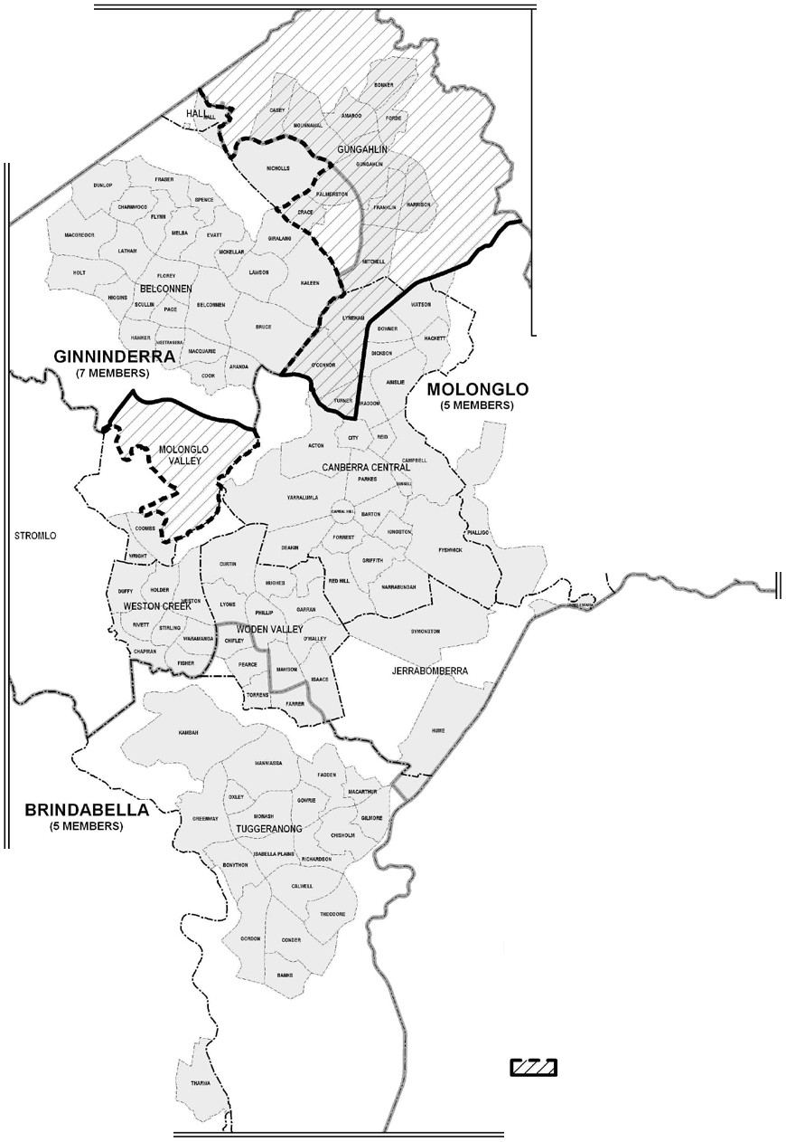

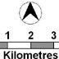

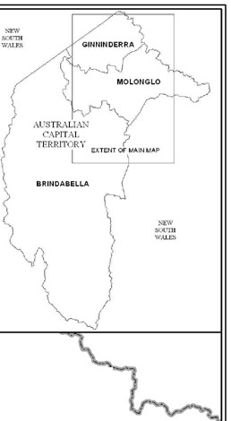

Map 1

New South Wales

MAJURA
I
i
/ i i
j
i
i
i
I
i KOVIEN
/'
)
i
\

New South Wales

PADDYS RIVER

LEGEND

0 4

ACT Plannlne &
1
Land Authority
Boundaries of Electorates Division Boundaries District Boundaries
Existing Boundary to Change

Proposed Change

The Committee considered that this option had merit in that it combined the whole of the districts of Belconnen and Gungahlin with a discrete set of (north) Central Canberra suburbs – Lyneham, O’Connor and Turner – that had close connections with each other and which were delineated from the rest of Central Canberra by the major multi-lane thoroughfares of Northbourne Avenue and Barry Drive. The Committee also noted that two of these three suburbs were immediately adjacent to the Belconnen suburbs of Kaleen and Bruce, that they shared access to O’Connor Ridge Nature Park and that they had strong transport links along Belconnen Way, Ginninderra Drive and the Barton Highway. The Committee also noted these areas had a range of other connections due
to their proximity, including access to schools, shops, sporting facilities and Calvary
Hospital.

The Committee also considered that Gungahlin and Belconnen had stronger links with each other than Gungahlin had with the further reaches of the existing Molonglo electorate, stretching as it does from Gungahlin through Central Canberra to Woden and Weston Creek.

If this option was adopted, the Committee also considered that this option could in the longer term see the Central Canberra suburbs return to Molonglo as Gungahlin increased in size.

However, the Committee notes that this option would significantly violate the principle of giving regard to the boundaries of existing electorates, with its implicit value of minimising changes to electoral boundaries and providing stability of boundaries. The Committee notes that this option would involve the transfer of around 31,600 electors from Molonglo to Ginninderra on current enrolment. (By contrast, the proposal to transfer Palmerston and Crace would involve the transfer of around 4,000 electors.) This option would also have the significant consequence of moving the location of the
7 Member electorate.

The Committee is also concerned that this option would significantly disrupt the community of interests that Lyneham, O’Connor and Turner share with neighbouring (north) Central Canberra suburbs. As the various Central Canberra suburbs were developed and settled much earlier than the suburbs of Belconnen and Gungahlin, it is arguable they have much more in common with each other than they do with the suburbs developed more recently. For example, it could be argued that Lyneham,
Turner and O’Connor have much closer connections to the university precinct of Acton, the adjacent City area and the neighbouring suburbs of Braddon, Dickson, Downer and Watson than they do with Belconnen or Gungahlin.

For the above reasons, the Committee concludes that it could not propose this change to the existing boundaries.

However, the Committee also notes the strength of feeling of those who are concerned that the existing electorate of Molonglo is too large, stretching as it does from Gungahlin to Weston Creek, and that it splits the growing district of Gungahlin. The Committee also recognises that the preferred alternative to this option would further split Gungahlin between Molonglo and Ginninderra.

The Committee therefore invites the ACT community to comment on the above option in the objection stage of this redistribution process. Should significant community support for this (or another) change emerge during the objection process, the Augmented Commission would have the option of rejecting the proposal of this Committee and substituting its own proposed redistribution. If that were to occur, the Electoral Act would require the Augmented Commission to conduct a further round of
objections should the Augmented Commission’s proposal be significantly different from the proposal made by this Committee.

Inclusion of the district of Molonglo Valley in one electorate

The Committee notes that the new district of Molonglo Valley is currently split between the electorates of Ginninderra and Molonglo. By the time of the October 2012 election, the only suburbs expected to be occupied by residents will be the suburbs of Coombs and Wright, both within the current electorate of Molonglo.

A general principle has been expressed at every redistribution conducted for the ACT Legislative Assembly that ACT districts constitute discrete communities of interests; therefore districts should not be split between electorates where possible. In order to be consistent with this principle, the Committee considers that it would be appropriate at this redistribution to alter the Ginninderra-Molonglo boundary to ensure that the whole of the district of Molonglo Valley is within one electorate.

As the only Molonglo Valley suburbs that will be developed at the time of the next election are currently in the electorate of Molonglo, and as those suburbs, Coombs and Wright, are adjacent to the Weston Creek suburbs of Duffy and Holder, the Committee considers that it would be appropriate to include all of the district of Molonglo Valley in the electorate of Molonglo. The Committee notes that this change will affect 4 currently enrolled electors in this area, who are all resident at the National Zoo and Aquarium. These 4 electors will be transferred from Ginninderra to Molonglo under the Committee’s proposal.

Therefore, as part of its proposed redistribution, the Committee is proposing that the portion of the district of Molonglo Valley north of the Molonglo River be transferred from the electorate of Ginninderra to the electorate of Molonglo.

Changes to the number of Members to be elected in each electorate

The submissions from the Gungahlin Community Council and from Mr Farrell suggested a change in the number of Members elected in the various electorates. The Committee notes that it does not have any power under the Electoral Act to consider this as a viable option in making its proposed redistribution. Section 34 of the Electoral Act specifies that the ACT must be divided into one electorate returning 7 Members, and
two electorates returning 5 Members.

The Committee notes the ACT Electoral Commission’s 30 April 2002 Submission to the ACT Legislative Assembly Standing Committee on Legal Affairs Inquiry into the appropriateness of the size of the Legislative Assembly for the ACT and options for changing the number of members, electorates and any other related matter, available at www.elections.act.gov.au/resources/uploads/pdfs/sizeofassemblysubmission.pdf. This

submission expressed the Commission’s view that the following two principles would further enhance the ACT’s electoral system:

• Electorates should each return the same number of Members; and

• The total number of Members should be an odd number – accordingly there should be an odd number of electorates.

This Committee notes adoption of these principles would have the beneficial effect of removing the issue of where to place unequal sized electorates from consideration at future redistributions.

Conclusion

While the Committee is mindful of, and sympathetic with, the arguments in favour of keeping Gungahlin suburbs together in the one electorate, the Committee views the transfer of Palmerston and Crace from Molonglo to join Nicholls in Ginninderra as the minimum change necessary to ensure that each electorate is within the required statistical allowances. It would also minimise public confusion and maintain continuity of existing boundaries as far as practicable.

The Committee notes that there are strong links between Nicholls and Palmerston, as they were among the first Gungahlin suburbs developed and those suburbs and the newer suburb of Crace share transport links with and proximity to Belconnen, being the closest Gungahlin suburbs to Belconnen. The Committee also notes that placing the revised electorate boundary around Palmerston and Crace along Gungahlin Drive will present a clear and obvious boundary.

In considering the available options, the Committee is of the view that the transfer of Palmerston and Crace from Molonglo to Ginninderra is the best available change that will ensure that the requirements of the Electoral Act are met.

For the purpose of keeping the new district of Molonglo in the one electorate, the Committee also proposes that the portion of the district of Molonglo Valley north of the Molonglo River be transferred from the electorate of Ginninderra to the electorate of Molonglo.

Names of electorates

In the first distribution of electoral boundaries in 1993, the then Committee also had the duty to propose names for the electorates. In naming the electorates the Committee was sensitive to the need to avoid confusion with Commonwealth electoral divisions and took cognisance of names that had a common theme and some tangible connection with their respective electorates. The names adopted in 1993 would appear to have gained general community acceptance.

None of the submissions received canvassed changing the names of any of the electorates.

The Committee notes that the new district of Molonglo Valley will be populated by the time of the 2012 election. The name of this district has the potential to be confused with the name of the electorate of Molonglo. However, in the absence of any public submissions expressing concern that the naming of Molonglo Valley could cause confusion, the Committee does not consider that there is a need to alter the name of the electorate of Molonglo at this time. However, should public concern be expressed
during the objection stage of this redistribution, the Augmented Commission may wish to address this issue when making its proposal.

The Committee accordingly proposes that Brindabella, Ginninderra and Molonglo be retained as the respective names of the southern, north-western and central electorates of the Australian Capital Territory.

Redistribution Committee for the Australian Capital Territory
Phillip Green — Neil Savery — Bill Hirst— Stephen Collett

5 May 2011

Appendix A: Constitution of Proposed Electorates

Proposed Electorate of Brindabella

Suburb | Actual persons enrolled  31 March 2011 | Projected persons enrolled  20 October 2012 | % change
Banks | 3390 | 3951 | 16.55%
Bonython | 2654 | 2831 | 6.67%
Calwell | 4219 | 4402 | 4.34%
Chifley | 1714 | 1764 | 2.92%
Chisholm | 3848 | 3709 | -3.61%
Conder | 3498 | 4084 | 16.75%
Fadden | 2477 | 2323 | -6.22%
Farrer | 2554 | 2489 | -8.70%
Gilmore | 2014 | 1964 | -2.48%
Gordon | 5447 | 6193 | 13.70%
Gowrie | 2451 | 2371 | -3.26%
Greenway | 1098 | 1199 | 9.20%
Isabella Plains | 2974 | 3008 | 1.14%
Kambah | 11702 | 11101 | -5.14%
Macarthur | 1173 | 1184 | 0.94%
Monash | 4188 | 4369 | 4.32%
Oxley | 1309 | 1309 | 0.00%
Pearce | 1913 | 1925 | 0.63%
Richardson | 2245 | 2166 | -3.52%
Theodore | 2728 | 2898 | 6.23%
Torrens | 1666 | 1677 | 0.66%
Tuggeranong - SSD Bal | 26 | 22 | -15.38%
Wanniassa | 5921 | 5591 | -5.57%
Remainder of ACT | 220 | 187 | -15.00%
Total | 71429 | 72717 | 1.80%
Quota | 72984 | 75343
Variation from quota | -2.13% | -3.49%

Proposed Electorate of Ginninderra

Suburb | Actual persons enrolled  31 March 2011 | Projected persons enrolled  20 October 2012 | % change
Aranda | 1831 | 1836 | 0.27%
Belconnen Town Centre | 2451 | 2843 | 15.99%
Belconnen - SSD Bal | 26 | 30 | 15.38%
Bruce | 3146 | 3659 | 16.31%
Charnwood | 2101 | 2052 | -2.33%
Cook | 2176 | 2180 | 0.18%
Crace | 97 | 112 | 15.46%
Dunlop | 4519 | 5218 | 15.47%
Evatt | 4049 | 3865 | -4.54%
Florey | 3610 | 3656 | 1.27%
Flynn | 2605 | 2458 | -5.64%
Fraser | 1632 | 1541 | -5.58%
Giralang | 2567 | 2425 | -5.53%
Hall | 236 | 228 | -3.39%
Hawker | 2202 | 2102 | -4.54%
Higgins | 2250 | 2137 | -5.02%
Holt | 3474 | 3602 | 3.68%
Kaleen | 5676 | 5330 | -6.10%
Latham | 2768 | 2630 | -4.99%
McKellar | 2138 | 2161 | 1.08%
Macgregor | 3376 | 4088 | 21.09%
Macquarie | 1807 | 1819 | 0.66%
Melba | 2432 | 2448 | 0.66%
Nicholls | 4986 | 5151 | 3.31%
Page | 2021 | 2014 | -0.35%
Palmerston | 3904 | 4212 | 7.89%
Scullin | 1983 | 1859 | -6.25%
Spence | 1933 | 1836 | -5.02%
Weetangera | 1979 | 1926 | -2.68%
Total | 73975 | 75418 | 1.95%
Quota | 72984 | 75343
Variation from quota | 1.36% | 0.10%

Proposed Electorate of Molonglo

Suburb | Actual persons enrolled  31 March 2011 | Projected persons enrolled  20 October 2012 | % change
Acton | 353 | 368 | 4.25%
Ainslie | 3837 | 3973 | 3.54%
Amaroo | 3552 | 3688 | 3.83%
Barton | 839 | 928 | 10.61%
Bonner | 278 | 523 | 88.13%
Braddon | 2735 | 3157 | 15.43%
Campbell / Duntroon / Majura | 3952 | 3943 | -0.23%
Casey | 341 | 723 | 112.02%
Chapman | 2191 | 2087 | -4.75%
City | 918 | 1060 | 15.47%
Curtin | 3908 | 3975 | 1.71%
Deakin | 2108 | 2127 | 0.90%
Dickson | 1431 | 1482 | 3.56%
Downer | 2467 | 2498 | 1.26%
Duffy | 2390 | 2260 | -5.44%
Fisher | 2342 | 2314 | -1.20%
Forde | 761 | 862 | 13.27%
Forrest | 1126 | 1156 | 2.66%
Franklin | 1412 | 2961 | 109.70%
Fyshwick | 23 | 21 | -8.70%
Garran | 2281 | 2342 | 2.67%
Griffith | 3130 | 3306 | 5.62%
Gungahlin | 3112 | 3513 | 12.89%
Gungahlin-Hall - SSD Bal | 16 | 16 | 0.00%
Hackett | 2259 | 2299 | 1.77%
Harman | 34 | 38 | 11.76%
Harrison | 2506 | 2790 | 11.33%
Holder | 2079 | 1978 | -4.86%
Hughes | 2140 | 2196 | 2.62%
Hume | 6 | 7 | 16.67%
Isaacs | 1871 | 1948 | 4.12%
Jerrabomberra | 8 | 9 | 12.50%
Kingston | 2224 | 2368 | 6.47%
Kowen | 25 | 26 | 4.00%
Lyneham | 3319 | 3451 | 3.98%
Lyons | 1825 | 1873 | 2.63%
Mawson | 2174 | 2205 | 1.43%
Mitchell | 8 | 8 | 0.00%
Molonglo Valley – SSD Bal | 4 | 4 | 0.00%
Narrabundah | 4153 | 4298 | 3.49%
Ngunnawal | 6000 | 6187 | 3.12%
Oaks Estate | 198 | 174 | -12.12%
O`Connor | 3811 | 3942 | 3.44%
O`Malley | 666 | 685 | 2.85%
Parkes | 3 | 3 | 0.00%
Phillip | 1372 | 1558 | 13.56%
Pialligo | 92 | 95 | 3.26%
Red Hill | 2297 | 2340 | 1.87%

Proposed Electorate of Molonglo

Suburb | Actual persons enrolled  31 March 2011 | Projected persons enrolled  20 October 2012 | % change
Reid | 1107 | 1139 | 2.89%
Rivett | 2358 | 2383 | 1.06%
Russell | 0 | 0 | 0.00%
Stirling | 1486 | 1433 | -3.57%
Stromlo | 4 | 5 | 25.00%
Symonston | 329 | 333 | 1.22%
Turner | 2478 | 2535 | 2.30%
Waramanga | 1926 | 1825 | -5.24%
Watson | 3617 | 3733 | 3.21%
Weston | 2454 | 2416 | -1.55%
Weston Creek-Stromlo - SSD Bal | 28 | 26 | -7.14%
Yarralumla | 2379 | 2440 | 2.56%
Total | 102743 | 108033 | 5.15%
Quota | 102178 | 105480
Variation from quota | 0.55% | 2.42%

Appendix B: Copies of public suggestions

Suggestions lodged with the Redistribution Committee pursuant to section 41(1)(a) of the Electoral Act 1992:

1. Elias Hallaj, Secretary
Australian Labor Party (ACT Branch)
page 28

2. Alan Kerlin, Spokesman – Planning, Transport and Environment, Gungahlin Community Council
page 30

3. Jonathon Reynolds page 34

4. Bogey Musidlak, Convenor
Proportional Representation Society of Australia (ACT Branch)
page 43

5. Tony Farrell page 47

6. Tom Anderson, Deputy Chairman, Weston Creek Community Council
page 49

Note: These suggestions were submitted using a variety of media and have been reformatted for this publication. The content is identical to the original submission and every effort has been made to preserve the original format.

No comments on these suggestions were lodged with the Redistribution Committee pursuant to section 41(1)(b) of the Electoral Act 1992.



Phil Green
Electoral Commissioner ACT Electoral Commission North building,Civic Square
London Circuit,Canberra City ACT 2601

AUSTRALIAN L ABOR PARTY

Australian Cap1talTcrntory Branch

Submission to Redistribution Committee ACT ElectoralCommission

Dear Redistribution Commti tee members,

Imake the following submission to the Redistrbi ution Committee as the Secretary and Registered
Officer of ACT Branch of the Australian Labor Party.

I must begin by acknowledging the professionalism displayed by Elections ACT in its role of providing high quality electoral services that ensure fair and open elections for our community in our unique representative system of democracy and government.

There is currently a very passionate debate being undertaken regarding the democratic rights of ACT residents.One of the reasons that these rights are cherished is that our government agencies and authorities have nurtured confi dence in our unique system of government. ACT residents have now experienced 21 years of self-government sni ce 1989 and 5 Hare-Clark elections since 1995.They better understand the voting opportunities and representative limitations our system provides. There is an "emerging maturity" and pride in our system of government and a growing public acceptance that the Hare-Clark system can provide opportunities for public representatives to work more cooperatively.

One of the key representative limitations is that due to the size and current composition of the three Assembly electorates a uniform "community of interest" which binds each electorate is not readily identifiable. This is somewhat inevitable when there are only three electorates and there are more than three distinct town centres,significant natural boundaries and numerous suburban precincts.

If you asked Canberrans where they lived they normally identify mostly with their nearest town centre or actual suburb,never with their Assembly electorate. Smaller and more numerous electorates that still retained proportional representation would improve "community of interest" whilst retaining the unique character and objectives of a unicameral Hare-Clark parliament.

The ACT Branch of the Labor Party has always been a very vocal advocate for individualand communal democratic rights and championed systemic improvements to our unique model of representative democracy.To be effective that advocacy must acknowledge the contextual factors which affect the universal franchise we enjoy in our community.

www.actlabor.org.au

AC18RANCH OFFICI HIRR!NS Sl8R!ON ACl • GPO BOX 30&5 CAHBERRAACT2601 • AB1' 438 540 751 T (02) 6247 4066 F (02)62473865 E inlo@act.alp.txgau

As in previous submissions,ACT Labor believes that although there is a long-term need for more substantial reform,the stability of the current electoral structure serves to increase the public confidence in the admni istration and outcomes of Territory Elections.

In the past,all three current ACT politicalparties have argued for an increase in the size of the ACT Assembly.An increase in the future is inevitable.

The recently released ACTPS Review stated "ACT residents remain significantly under-represented today in comparison to the rest of Australia." At a combined state and localgovernment level, representation in the ACT is 1:14,28S compared to Tasmania at 1:1,110 and the Northern Territory at 1:685.

The review lists various reasons why an increase in the size of the Assembly and Executive would benefit governance and accountability,including enabling Members "to serve their constituents better" and enhancing the "capacity of the legislature to scrutinise the activities of the Executive".

However the wholesale reform of the Assembly size and design is not practical at this stage in the
ACT's electoral cycle.

Moving a smallnumber of suburbs between electorates would minimise the possibility that the proposed redistribution would generate many objections and would also improve the likelihood of wider support for more substantialreform in the future by minimising the disruption that would be caused by a significant change now as well as one in the near future.

In these circumstances a significant change to the current boundaries will compound the confusion that already exists regarding Assembly electorates and community of interest objectives. Although fundamental weaknesses regarding community of interest in the existing system cannot be fixed through redistribution,a short-term solution is needed to enable next year's election to proceed with as little disruption and as much notice and fairness as possible.

ACT Labor therefore requests that the Redistrbi ution Committee seek a minimalist approach to boundary changes that will provide greater confidence in the existing system,boundaries and in the management of ACT electoralregulati ons.This would also be prudent given the current Senate debate around the ACT Assembly's rights to determine the size of its own legislature.

Yours sincerely,

Elias Hallaj r
C&/4·
Secretary,ALP (ACT Branch)

09/03/11

2
I
I

Dear Mr Green

Followi ng are ou r suggestions regardin g the redistribution of electoral boundaries for the
ACT.

However, we should say at the outset that we feel most of this process will be in vain, and the comm ittee will default to the "least change" approach it did last time around. The problem with that approach of course is that it does not fix the problem in a lasting manner, as evident from the fact that we need more changes just three years later. The i ncremental approach does not account for the rapid population growth in the north.

And the core problem will remain: the seven-member Molonglo electorate will rema i n geographically sprawling from almost Tuggeranong, throu gh Weston, Woden, central Canberra and circling around Belconnen through most (but not a ll) of Gungahlin. There will remain some MLAs representing parts ofGungahlin who know little of the Gungahlin community's issues, and if we are frank seldom set foot in Gungahlin.

Our preferred approach is for the ACT to have additional MLAs. As we explained during the last redistiibution, it is evident to us that the workloads involved with a 17-mernber Assembly are unacceptable, leading to i nadequate decisionmaking that may not have occurred if there was better oversight and issue knowledge by m i nisters with less demanding portfolios. We note that not one Government MLA has attended a single GCC meeting since the last
election, and rare conversations our representatives have had with them at functions etc make
it clear that some are falling out of touch with the community they represent. It has also been argued that some of the problem stems from lack of depth within the Government "back bench". Similar arguments can be put forward regarding the q uality of opposition resulting from the small Assembl y depth.

We have attempted to stim ulate public debate on the issue of Assembl y size, but have been disappointed by the lack of support or even interest from many i ncumbent MLAs. We wou l d have thought that if there was one issue for which they could put aside grandstanding in favour of a united approach to the Federal Government supporting a better solution for the people of the ACT, then this would be it. It seems not.

As can be seen from the attached output from our electorate modelling software, five electorates offive M LAs each with quotas of approximately I 0,000 electors can be easily achieved . These electorates can al ign closel y to established communities of interest: Belconnen, North Canben·a/Gungahl i n, Central Canberra, Weston/Woden, and Tuggeranong. Each possible electorate is geographically constrained, which woul d give elected members
far better opportunity to closely engage with the community they represent.

However, as previously stated, it seems the parliament hasn't the mood to pursue such an i mprovement, so we will be stuck with a 7-5-5 Assembly, wi th a quota of about 15,000 electors- an increase of 1000 per MLA from the current term. Given that unfortunate situation, we have sought a solution that aligns communi ties of interest as closel y as possible, while preserving a small negative variance where the grov,rth will be greatest over the next eight years - Gungahlin, hopefully minimising the need for another redistribution next term.

The attached output shows a five-member electorate covering Tuggeranong and Weston
(nominally Brindabella), and a second five-member electorate with all of Woden and the

Inner South, plus the Inner North (Molonglo).

The seven-member Ginninderra electorate would entirely encompass Belconnen and Gungahlin- areas with many common issues, characteristics and challenges. Watson from north Canberra wou ld make up the numbers, recognising that this suburb is heavily used by Gungahlin people, who frequent its schools, childcare centres and shops. The electorate would be five per cent under variance initially, well under the 10 per cent requirement. This would absorb significant Gungahlin population growth without the need for redistribution. Further out, and assuming still no solution for increasing the Assembly si ze, Gungahlin will grow to the extent that Watson could be moved from Ginninderra to Molonglo.

Similarly, this solution has Molonglo with a 1 .6 per cen t negative variance, sufficient to absorb population growth in the new suburbs of Molonglo. Brindabella electorate would start the term with a 7.6 per cent over variance, also under the I 0 per cent requirement, and sufficient to buffer the popu lation expansion in the other electorates, most likely for more
than one term.

A similar al ternative would have Brindabella as a fi ve-member electorate covering Tuggeranong and up to Hindmarsh Drive, and Molonglo from Woden and Weston, through the Inner South and I nner North, but with the two suburbs of Lyneham and Watson incorporated into Ginninderra. The variances for this option are smaller though, and would therefore be less resilient against likely population growth.

We would be pleased to further explain our proposals. Regards,
Alan Kerlin
Gungahlin Community Council
Spokesman - Planning, Transport and Environment
m 0408 771633

10 March 2011

- . .. o=
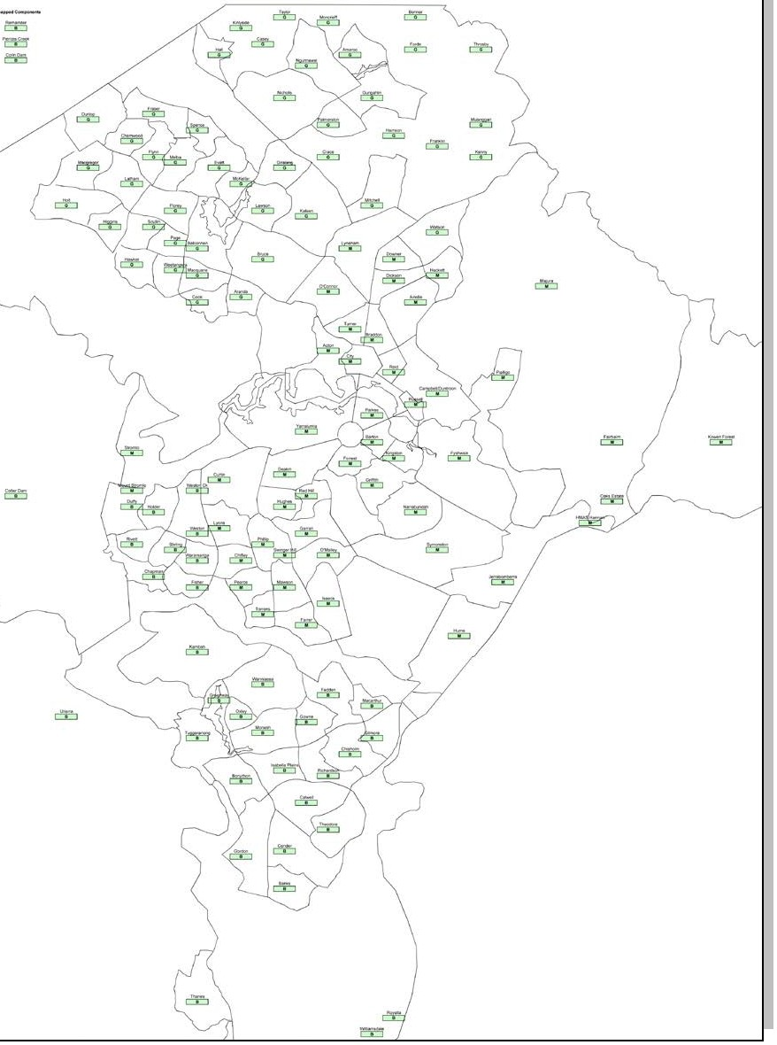

• . .

;.:::t:z::.:-:-=

-· .
::::.:=:·:=.=-=-=::-::-.:-::.:.:=!.'.*.--

o=
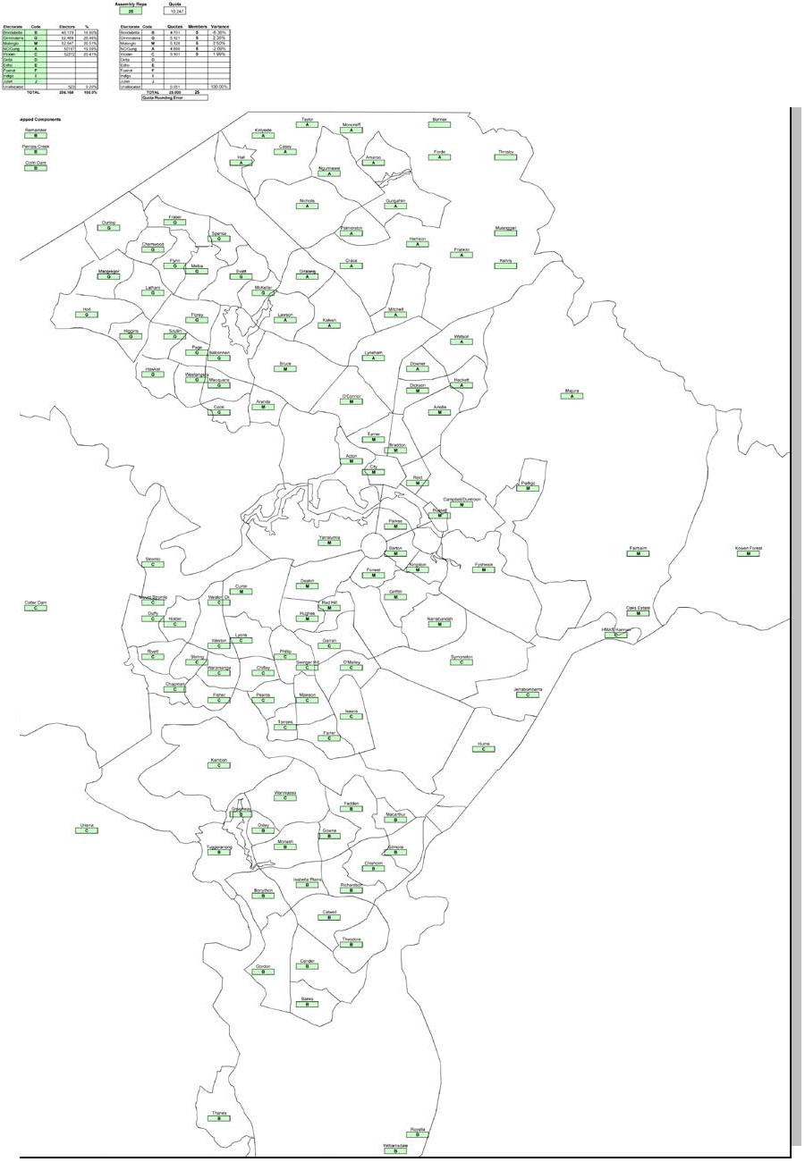

::::.:=:·:=.=-=-=::-::-.:-::.:.:=!.'.*.--
;.:::t:z::.:-:-=

Dear Sir/Madam,

Please find attached three suggested models for the redistribution of the current ACT Electoral Boundaries.
These proposed boundaries suggestions have been presented in both spreadsheet and graphical fonnats (as attached).

Model l: Minimal Change
This model proposes the minimal changes that would be required to meet the criteria for a possible redistribution. This is the least optimal choice as it further exacerbates the current inadequacies of the current electoral boundaries further fragmenting the districts of
Gungahlin and Woden Valley across two electorates and uses boundaries that at times are not immediately logical when considering the divisions and sections as defined under the Districts Act 2002. The means of communication and travel within each proposed electorate remain complicated and for the electorate of Molonglo there is little sense in the physical features of the electorate as it encompasses several multiple disparate Districts across the N01th, Central and Southern Areas of Canberra. This model is included for illustrative purposes only and not put forwarded as a recommended solution to any proposed boundary redistribution.

Modd 1 Compliance with Legislative Requirements:

• Complies: ensure that the number of electors in an electorate immediately after the redistribution is within the range of not greater than 110%, or less than 90% of the quota;
• Complies: endeavour to ensure, as far as practicable, that the number of electors in an electorate at the time of the next general election of members of the Legislative Assembly will not be greater than 105%, or less than 95%, of the expected quota for the electorate at that time;

Model 2: Northern, Central and Southern Electorates (Molonglo Adjustments)
This model proposed making Molonglo a 5 member electorate and Ginninderra a 7 member electorate. Redistribution is limited to reallocating sections as defined under the Districts Act
2002 ofthe March 2010 Molong\o electorate only. It attempts to create a notion of clearly defined Northern (Ginninderra), Central (Molonglo) and Southern (Brindabella) electorates. Portio·ns of North Canberra are incorporated into the Northern Electorate with the intent that they will return to the central electorate as the District ofGungahlin continues to grow significantly. These areas of North Canberra is clearly delineated by major axis roads. It makes no attempt to rectifY the problems of splitting the district of the Woden Valley across two electorates at th is time. Longer term redistri bution problems will arise as the new district of Molonglo develops and population increases thus further potentially splitting the community in the Woden Valley in future redistributions.

Modd 2 Compliance with Legislative Requirements:

• Complies: ensure that the number of electors in an electorate immediately after the redistribution is within the range of not greater than 110%, or less than 90% of the quota;
• Complies: endeavour to ensure, as far as practicable, that the number of electors in an electorate at the time of the next general election of members of the Legislative Assembly will not be greater than 105%, or less than 95%, of the expected quota for the electorate at that time;

Mode·l 3: Northern, Central and Southern Electorates (Molonglo
& Brindabella Adjustments)
This model proposed making Molonglo a 5 member electorate and Ginninderra a 7 member
electorate. Redistribution involves reallocating sections as defined under the Districts Act
2002 of the March 2010 Molonglo and Brindabella electorates. It attempts to create a notion of clearly defined Northern (Ginninderra), Central (Molonglo) and Southern (Brindabella) electorates with a clear view for further growth within and of these electorates. Portions of North Canberra are incorporated into the Northern Electorate with the intent that they will return to the central electorate as the District ofGungahlin continues to grow significantly. These sections of North Canberra that are incorporated in the proposed new Ginninderra electorate are clearly bounded by major axis roads. Portions of the Woden Valley currently in Brindabella are returned to the Molonglo (central) electorate thus ensuring that the
community of interest is returned to a fully intact state within a single electorate. The southern portion of Weston Creek is split along a major axis road. Whilst this change currently splits the Weston Creek district it is envisioned that as the new Molonglo district grows the entire area of Weston Creek to the north of the proposed split wou ld be further redistributed into the Brindabella electorate thus maintaining the concept of clearly defined Central and Southern electorates and communities of interest. This is my preferred redistribution model of the three being proposed.

Modd 2 Compliance with Legislative Requirements:

• Complies; ensure that the number of electors in an electorate immediately after the redistribution is within the range of not greater than 110%, or less than 90% of the quota;
• Complies: endeavour to ensure, as far as practicable, that the number of electors in an electorate at the time of the next general election of members of the Legislative Assembly will not be greater than 105%, or less than 95%, of the expected quota for the electorate at that time;

I trust that this submission meets wi th your approval.
I look forward to your positive consideration of these suggestions. Yours faithfully
Jonathon Reynolds

10 March 2011

"..'."."..

KOWEH

STROlllO

PAllOYSRIVER
Redistribution of the
AustraUan CspitalTerritory into electorates pursuant to the Electoral Act 1992

Electorates for the
ACT Legislative Assembly
of BRINDABELLA, GINNINDERRA
and MOLONGLO

0,....1.-

A
2_,.3---,

Boundaries of Electorates Division Boundaries District Boundaries

Kilometres
Roger Beale AO
Phillip Green Ch rislabel Young

...J' --...( 1A.aCnTdPlanninQ: &
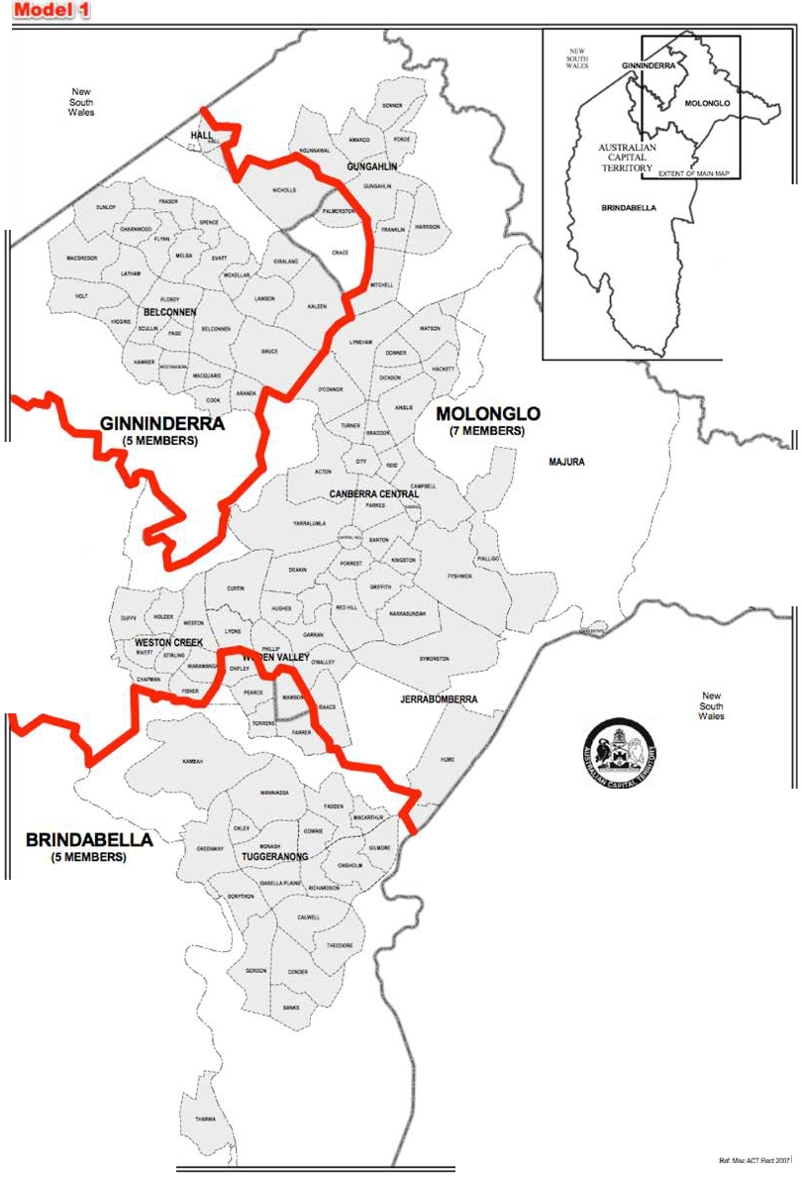

Aut!Wity
-
'
NeSavery Bill Hirst

Augmented ACT EleCIOralCommission
Allgusl2007

"..'."."..

KOWEH

STROlllO

PAllOYSRIVER
Redistribution of the
AustraUan CspitalTerritory into electorates pursuant to the Electoral Act 1992

Electorates for the
ACT Legislative Assembly
of BRINDABELLA, GINNINDERRA
and MOLONGLO

0,....1.-

A
2_,.3---,

Boundaries of Electorates Division Boundaries District Boundaries

Kilometres
Roger Beale AO
Phillip Green Ch rislabel Young

...J' --...( 1A.aCnTdPlanninQ: &
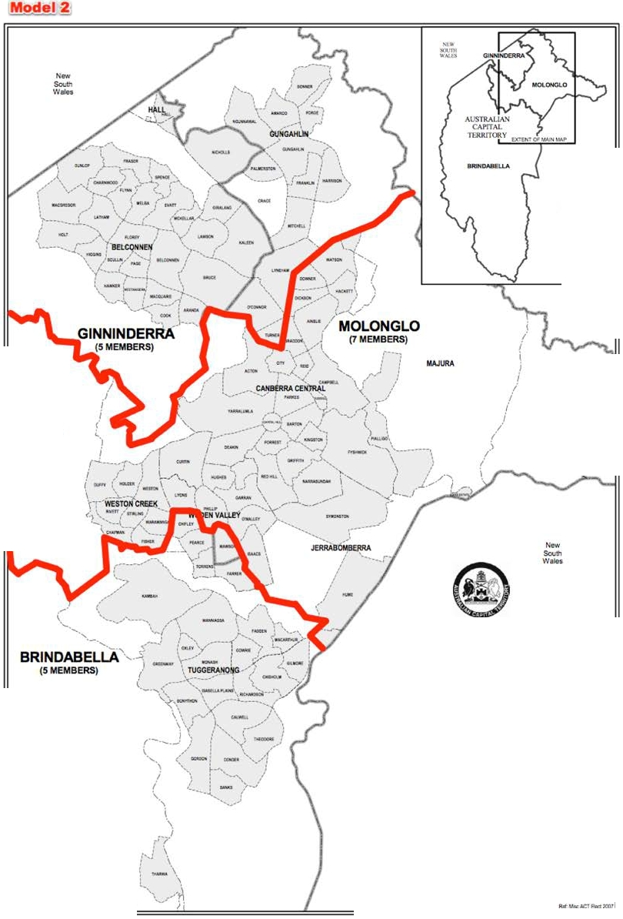

Aut!Wity
-
'
NeSavery Bill Hirst

Augmented ACT EleCIOralCommission
Allgusl2007

"..'."."..

KOWEH

STROlllO

PAllOYSRIVER
Redistribution of the
AustraUan CspitalTerritory into electorates pursuant to the Electoral Act 1992

Electorates for the
ACT Legislative Assembly
of BRINDABELLA, GINNINDERRA
and MOLONGLO

0,....1.-

A
2_,.3---,

Boundaries of Electorates Division Boundaries District Boundaries

Kilometres
Roger Beale AO
Phillip Green Ch rislabel Young

...J' --...( 1A.aCnTdPlanninQ: &
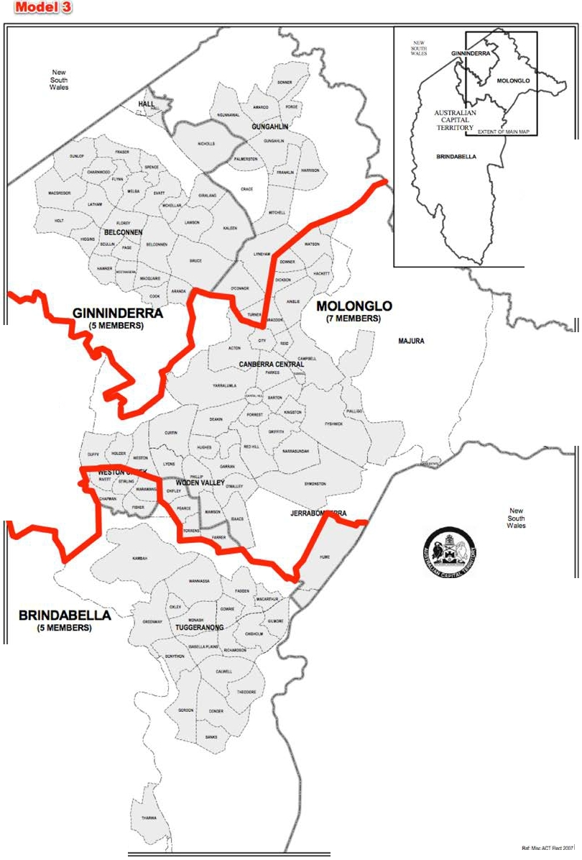

Aut!Wity
-
'
NeSavery Bill Hirst

Augmented ACT EleCIOralCommission
Allgusl2007

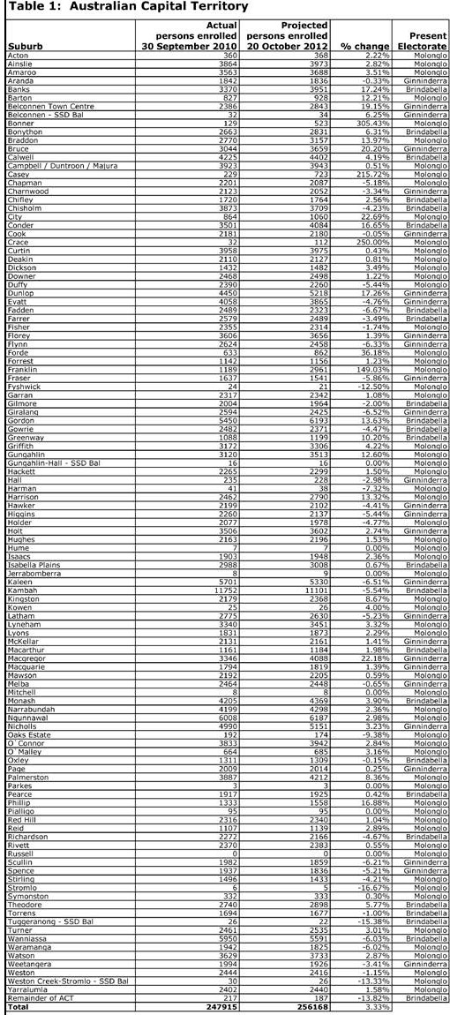

Current and Projected Numbers Persons Enrolled

TOTAL
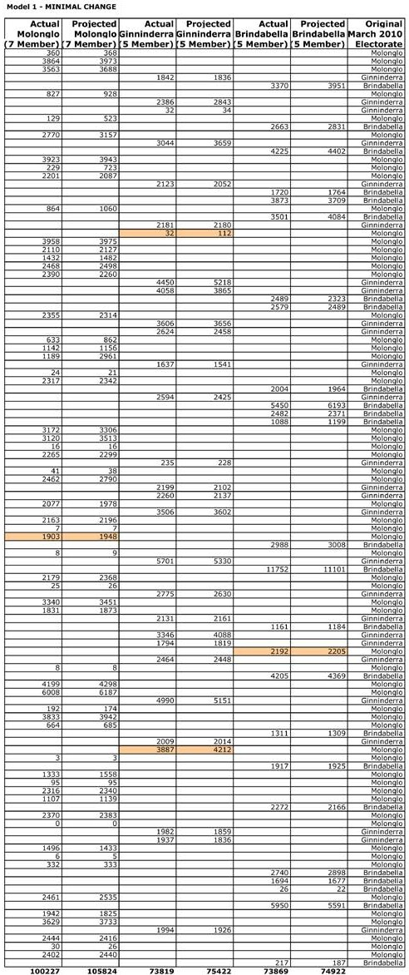

QUOTA
Varit nt;41
'o/eaQe of quota

10 08l
1855
1.82

105480
·344
·0.33%

7l916
·903
·1.24%

7$343
· ?9
..0.10%

72916
·953
·1.31%

75.)43
421
0.56%

Complies complies
enwre that the number 01 electors In an eleetota-e_ immediately attet the t6dittllbubon1:1 within U'le range oc not greatef than 110%.or less than 90% of the quota:
endeavour to ensure. a:a far a.a practicabSe,that the numbe:r of electOf& in aneleotorae at the time of the De.Xt generalelectiOn of members or the Legislative Assembly W'lll not be grea1er !han 105%,or less than95% oc the expected QUOta lor 1t1e etectorate at tha1time,

TOTAL
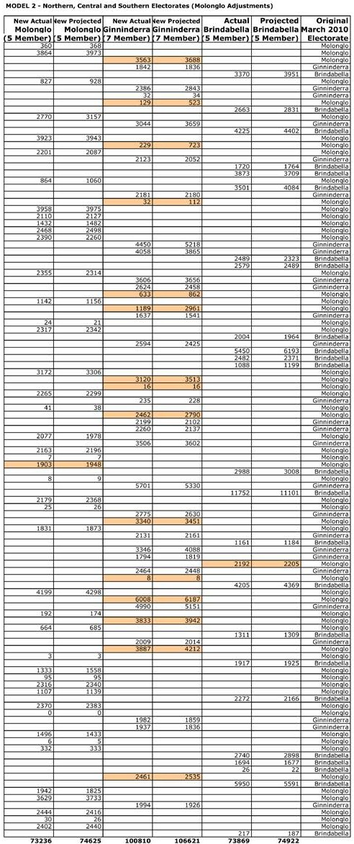

QUOTA
Varitnt;41
'o/eaQe of quota
72916
·320
·0.44

75343
718
0.95%
102082
1212
1.25%
105480
·1141
·1.08%

72916
·953
·1.31%

75.)43
421
0.56%

Complies complies
enwre that the number 01 electors In an eleetota-e_ immediately attet the t6dittllbubon1:1 within U'le range oc not greatef than 110%.or less than 90% of the quota:
endeavour to ensure. a:a far a.a practicabSe,that the numbe:r of electOf& in aneleotorae at the time of the De.Xt generalelectiOn of members or the Legislative Assembly W'lll not be grea1er !han 105%,or less than95% oc the expected QUOta lor 1t1e etectorate at tha1time,

TOTA.l
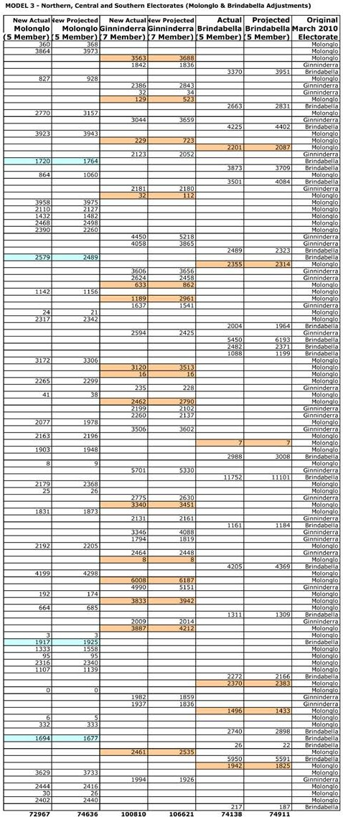

QUOTA
Vari.11nee
aqe: <If quota

72916
·51
+0.0
75343
707
0.9.,.,

102082
1272
1.25

105480
·1141
-1.08%

72916
·1222
·1.68%

75343
4l2
0.57%

COmpliet

COmplies
enM re that me numbet ot f!MctOta •n aneWtc4orate invnedlatetyafter tiM redl&tnbutlonb within lhe raof no4
grNter than 110%. otless than 90% of the qUOta:
enduvcxw to enwr..nfaras pra.c;fg.bk, that tt..nuof elec:tor5 inan rate at the time of the ne.xt genera1election of members of Che legislative Assemblyoot be greatef than 105%,or Seu than 95%. of the
expected quota fot 111e electorate at that ume;

Hello

Please fi nd attached a submission from the ACT Branch of the Prop01tional Representation Society of Australia arguing that in the current redistri bution process Palmerston and Crace shou l d be transferred from Molonglo to Ginn i nderra.

Bogey Musid lak

Convenor

10 March 2011

PROPORTIONAL REPRESENTATION SOCIETY OF AUSTRALIA (AUSTRALIAN CAPITAL TERRITORY BRANCH)

MOVE PALMERSTON AND CRACE FROM MOLONGLO TO GINNINDERRA

The Proportional Representation Society of Australia (Australian Capital Territory Branch) submits that, while conti nuing rapid growth i n Molonglo necessitates change to the existi ng electoral boundaries, the transfer of both Palmerston and Crace from Molonglo to
Gi nni nderra would satisfy legislative requirements about enrolments at the t i me of the next elecUon as well as maximisi ng utility for electors includ ing prospects of boundary stability in
2016.

An expectation of stable boundaries under Hare-Clark

The appreciation by voters of a high level of stability in electoral arrangements goes back to the start of the campaign for our voter-empowering Hare-Clark system. Expectations of
stable boundaries were repeatedly placed before the people when we were deciding the natu re of our future electoral system. For example, in the 1991 pamphlet How to make your vote really count, the Hare-Clark Campaign Committee prominently contrasted stable boundaries under Hare-Clark with frequent boundary changes under single-member electorates.

In the official case for the Proportional Representation (Hare-Clark) System sent to voters in
1992, the following comments were made in relation to stability (bold type face has been introduced to emphasise the key words in the current context).

A voting system should also provide stability a government with broad support should not be 'held to ransom' by parties with a very small share of the primary vote, nor should voters face constantly-changing electoral boundaries.

Under the ACT version of Hare-Clark, a quota of at least 12.5% of the vote will be needed to win a seat; this will exclude parties with very little popular support. Boundaries will seldom change.

Following implementation of the Hare-Clark system, to date the expectations of Hare-Clark supporters have been met. The ACT Branch of the Proportional Representation Society of Australia (ACT Branch) has been a strong supporter of minimising changes to ACT electoral boundaries, so long as the bou ndaries still provide for broadly equal representation:

in 1996 we were among the organisations submitting that there should be no change at all as a result of that review;
in 2000, along with the Li beral and Labor Parties, we suggested moving the suburb of Nicholls from Molonglo to Ginninderra in order to deal with t he projected imbalances at the time of the 2001 general elections if the previous boundaries had remained the same, and noted that the best-available population projections at the time ind icated no change would be needed in 2004;
in 2003, we argued for no change and suggested that the Committee recommend fast­ tracking be possi ble when current and projected populations fall within statutory tolerance limits and there has been no public agitat ion for bou ndary changes prior to the call for submissions;

• in 2007. we argued that, based on publicly-available information, there was no need for any change to electoral boundaries and urged fast-tracking of redistribu tion processes in such circumstances.

The ACT Branch is pleased that an earlier Redistribution Committee stated explicitly of its proposed transfer of Nicholls that "this is the minimum change necessary to ensure that each electorate is within the required statistical tolerance" and observed as a more general principle that "cha nge should affect as few electors as possible".

Most Redistribution Committees since the first set of boundaries came up for review in 1996 have adopted a similar approach. The ACT Branch continues to be heartened that voters' interests are being placed at the forefront of how the Hare-Clark system operates here, and that flawed proposals calling for extensive change have been duly examined but have received relatively short shrift in the past.

While the current boundaries do not satisfy all the relevant criteria, only minor adjustments are necessary

Australian Bureau of Statistics projections put enrolments in Ginninderra and Molonglo slightly beyond the statutory deviations allowed from the territory quota on the next election day, while those in Brindabella are comfortably within the available allowance.

In these circumstances there should be no change to Brindabella 's boundaries, while the necessary changes elsewhere can be and most appropriately should be effected by minor adjustments. Movi ng Palmerston from Molonglo to Ginninderra would result in Gin ninderra being almost precisely at quota in October 2012 based on ABS projections and Molonglo being just 2.5% above, a nd therefore satisfy the key statutory requ irement.

Under the Electoral Act, three criteria relating to proposed electorates that must be given due consideration by the Redistribution Committee are economic, social and regional community of interests, means of communication and travel, and physical features and area. These criteria are clearly intended to help identify natural communities and groupings of suburbs, taking account of the physical and social geography of the ACT.

In these circumstances, while movingjust Palmerston would address the imbalance in enrolments, the question arises of whether Crace should be moved also even though it is expected to have very few voters in October 2012.

The Proportional Representation Society of Australia (Australian Capital Territory Branch) believes that better boundaries for electors would arise if this step were taken now as Nicholls, Palmerston and Crace form a more natural standalone u nit geographically than would just Nicholls and Palmerston. Future growth in Crace could then result in boundary stability being a possible option when the next red istribution is undertaken as Ginninderra would have an area in wh ich rapid population i ncreases were occurring and receiving attention from at least some of its MLAs.

While projections that far ahead are necessarily speculative because of significant events that could occur in the intervening period, the Redistribu tion Committee might give thought to including some particulars of that nature under various plausible assumptions to further strengthen the case for also shifting Crace to Ginninderra before it is strictly necessary to do

so. Increasing the likelihood of continuity of representation within more stable boundaries as expansion within the suburb occurred would from the perspective of electors be agreeable grounds for including Crace in fairly minor adjustments to boundaries to be made on this occasion.

'!'o ny li'arl' ell ,
RECEIVED 1 J/8 Deffa Courts,

:FEB 2011

aeid , A .c.'1'.261 2

COMMISSKJM ph .( 02 ) 6247.1682
ACT ELECTORAL
2) .02 .11

1y propo sal is that Nicho lls sho u.ld be removed 1.':r.·om Ginninde-t"ra and re-u nited 1d th Gungahlin ,and hence t-l o lo nglo .f o r the tim e being,
and that Cht :fley,Poarce ,Torrens and arrer beremoved :from l:lrindabella

and also returned to Nolou g.to , and tha t the number o.f H< px·esentatives

.for f'lolo nglo sho u ld be rai,.ed f':com 'l t o 9 .

J.n ·1989 at the t im e o f' the f i rst ACT Legislative Assembly elections, the total enrolment o f' vo t ers tvas t 69 , '+9J . Tha t gave u o one rte preS<Htt- ative .f o r every 9 , 970.1764 voteJs , and there being on ly the one 0J.ect- ox·ate , regionaJ. dif'.f(,)rences l·lere not yet relevan t to til"' system itself', und hence were not considered .
J:n Janu ary of 2011 , the tota l o·f enrol.led votc:n.•s f'or Gin rlinderra

a\ s 69 , 929 - this 1';\'i ves ono Repr esentative .fo'l:' every '1 3 , 98.5 .8 vohn s.

In ,January of 2011 1 thA to tal of enroLl ed voters :for Drindabel:L a

Iu ,Tu.n u nry of :20·1 I , the to!;a.l o.r enrolled voters .for 14olonglo

was 106 , 502 - this give:J one Hop:c-esentat:lv' 1:'01 ovey·,

1 5 , 21h .571 voters .

,•:ven a.t.l.o•dng .f o1 the asau111pt ion thu.t the ori( ina.l :fra11101':; o.f the sys teul f'ore,:;a•.t t1'1a t the .ACT 1;ou.lcl grot·/ in popu lation as the yea r a
po. sed , u.ncl tlt:\ t around the ·1;, 000 umrlc lfOU.l.d eventually apply a!l the

nulllber of' vot•1-:rer !loprc!lentativc , as it S<ems fairly nor111a.L in si111ilar j u ris<lictions, th.H ,,ay tho current syst"t' has evolved has 11011 exposHd flo.w s in the system , both in a regional sense and a population
sonse .

l•a.t:'l'ell Submission to H .U. pag·e 2

·ly suggestion ir; that N;Lcho l l!J mo re JH'<>perly s lloul<l bo grouped as part of' Gungahlin,and hence part o:f Holonglo f'or. the 'time bc.in(; unti l s o111 e f utu r e o \edis'tl.':lbut:i.on Coonmi_ ttee 111ay deet u Gungahlin { an d J?Orhups l4a,iura , Kot{en , and even Oaks 'C:sta.te) to bo a populous l:'Ogioo in it 1 !} o•m r:i.gllt l;o ,ju:; tLf'y cons1;itut:lng a separc\te .O:lectot'ate.
;of:l th the lo Hs of Nicholls , this 11ould give Ginn:lnclort·a a total

of. 6L1 , 9h ·1 em.·ol.lod vot e rs on 20'1 1 f 'iguros,and consequently ·12,988 , ! vo te1:':J pe·r.- ,(epresen ta 'Cive . Ginnin lerra t·IOUld tf1en be regionally and cl<arly cle f iHed as Delconnen and :Ju l;)u rbs and the v:i.Lla ·e of llall .

Ny suggestion is that tho suburbs of' Chi:fley , Pea1·ce , Torrens Clnd Furrer have neve:r.- cuasHd to b< part o:f the Nolonc;lo r egi on , ancl sho uld be \'AtUl'nod . 'i'hat <10Ltlcl leave Brtndo.bclJ.u a total of 6:J , 67:J OJH'Olloct votura on 2011 .figuo s , and conuoqu 1tly 12 , 7J4 .6 voters pe r ep .As
1mll , Hrincl abella liOuld th<n regionally and c:l.early be d0.fitHJd as

1)Jc;c:oranong and subt.t ,·bn am.l tlw viLLag·c o:f 'C'hrt:t'\·T<t ,

'l.'hi:; HOt.tld g:i.ve -tolonglo a total of' 1 '19, JLJ1 voters on 2011 J"igures ,

Cln<'l clem ly divi.d i.ng by 7 is no long<:ll<'elevant .Hut dividing by 9

110uld utean that thero \>'ere 1:J , 260 , '1 '1 ·1 vot<H'S per ,epresen tative , a

:far more accepta blo option.As t{oll., l-'lolonglo I{Ould rcg:lonally an.d clearly be de.finect as the City and \oden and 'Choir suburbs , and l'or the tioue being Gun ,gahlin and Haj ura and \C01·1en and Oaks ls tate .

ThanIcing yo u for your consiclera tion o.r these sug({Of.l t:lon s ,

I remain ,

yoursincern;.Y,
(
1l''arrl .l

• • • weston creek
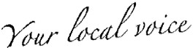

••
• community

RECEIVE'o

2 8 FEB 2011
ACTELEC
COMMrsifb l
•• council

www.wccc.com.au info@wccc.com.au

PO Box 3701
Weston Creek ACT 2611
Telephone (02) 6288 8975

The Redistribution Committee ACT Electoral Commission P.O. Box 272
CIVIC SQUARE ACT 2608

24 February 2011

Submission in Relation to the Proposed Electoral Boundaries for the ACT Legislative Electorates

I am writing on behalf of the Weston Creek Community Council (WCCC) in relation to the proposed boundaries for the ACT Legislative Electorates.

Weston Creek is a unique part of Canberra and is the smallest District in residential Canberra situated in a well treed valley some 3 kilometres wide and
4 kilometres long. It has been described as one of the most picturesque parts of the National Capital. Nei ther Council nor the .Community could contemplate Weston Creek being split between electorates. The ei ght suburbs are a community with the hub being the Cooleman Court precinct.

It would appear that the Commission in past elections has made decisions to move suburbs from their "Districts" to balance the quotas required for each, electorate. While WCCC appreciates the Commission has a difficult task in balancing electorates, it is also of the opinion that Weston Creek, unlike some other 'districts', is a homogenous area that does not readily lend itself to segregation. Rather, Weston Creek should be the starting point to determine boundaries with those 'districts' that do not have any particular defining features being used to balance the overall electorate requirements.

Io'Q:ka•ediscuss submission at any time.

Tom Anderson -
Deputy Chairman
Weston Creek Community Council

• Established 1991 • ABN: 52 841 915 317 •Weston Creek Citizens CouncilInc. • Reg. no. A 2637
Weston Creek Community Council is supported by the ACT Government

• • • weston creek  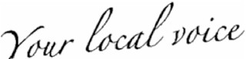 • community  •• council  www.wccc.com.au info@wccc.com.au  PO Box 3701  Weston Creek ACT 2611  Telephone (02) 6288 8975  The Redistribution Committee  ACT Electoral Commission 9 March 2011  P.O. Box 272  CIVIC SQUARE ACT 2608  Submission in Relation to the Proposed Electoral Boundaries for the ACT Legislative Electorates  This is a supplementary Submission on behalf of the Weston Creek Community Council (WCCC) in relation to the proposed boundaries for the ACT Legislative Electorates.  Further to my earlier Submission, I would like again to emphasise that Weston Creek is a single community and is better kept as a whole in the Molonglo Electorate. It would seem that at the last review, the Electoral Commissioners accepted this point of view as Weston Creek remained as a whole within the Molonglo Electorate. There is certainly a view that people in Weston Creek, if they have an affinity, it is with the Woden Valley rather than Tuggeranong and for shopping and bus routes this is certainly true.  WCCC notes that within the 'Legal Requirements for Redistribution', section C states that 5 matters must be considered. Items (i) and (ii) seem to cover the economic and social cohesion of an electorate and along with item (iii) point towards maintaining where possible the boundaries of what residents consider to be their 'area'. This seems to confirm the points made above and the view of the Commissioners previously.  In Table 4 there are no projected persons for either Wright or Coombs. Council understands that these areas are planned to be settled during 2012. Further, Council notes that there is a projected decrease in the suburb of Weston despite construction in the new North Weston area well under way and expected to be settled during 2012.  There is no question that the moving suburbs out of their District is one which is not accepted by the people who live there. However, the boundaries that are presently in place have been accepted by the population, al beit probably | J
• Established 1991 • ABN:52 841 915 317 • Weston Creek Citizens Council Inc. • Reg. no.A 2637  Weston Creek Community Councilis supported by the ACT Government | J

2  reluctantly in the southern Woden suburbs and in Nicholls in Gungahlin. WCCC suggest to keep any changes to a minimum that the suburbs of Palmerston and Crace be moved from the Electorate of Molonglo to the Electorate of Ginninderra. This will provide a very clear boundary between the two electorates and geographically seems to be the "right" boundary. This  move will then provide for the three electorates to be within the 5% of the projected quota for each Electorate. Council figures based on the information provided are as follows:  Quota for 1 member based on projections for 2012 is  256168 divided by 17 = 15068  Therefore the number of enrolled voters in each electorate should be: Molonglo- 15068 x 7 = 105476 enrolled voters [105480 in the guide]  Brindabella- 15068 x 5 = 75340 enrolled voters [75343 in the guide]  Ginninderra- 15068 x 5 = 75340 enrolled voters [75343 in the guide]  Council's suggestions would make the electorates as follows:  Molonglo 112353-4212 [Palmerston] - 112 Crace= 108029 + 2.42% Ginninderra 71098 + 4212 [Palmerston] + 112 Crace= 75422 + 0.11% Brindabella - as projected 72717 - 3.49%  Again I would just like to repeat that Council strongly supports keeping Weston Creek suburbs in the one electorate and that the Electorate be that of Molonglo.  Council would be pleased to discuss this submission at any time.  Tom Anderson  Deputy Chairman  Weston Creek Community Council | J
• Established 1991 • ABN:52 841 915 317 • Weston Creek Citizens CouncilInc. • Reg.no. A 2637  Weston Creek Community Council is supported by the ACT Govemment | J

