Dear Sir/Madam,

Please find attached three suggested models for the redistribution of the current ACT Electoral Boundaries.
These proposed boundaries suggestions have been presented in both spreadsheet and graphical formats (as attached).

Model 1: Minimal Change
This model proposes the minimal changes that would be required to meet the criteria for a
possible redistribution. This is the least optimal choice as it further exacerbates the current inadequacies of the current electoral boundaries further fragmenting the districts of
Gungahlin and Woden Valley across two electorates and uses boundaries that at times are not immediately logical when considering the divisions and sections as defined under the
Districts Act 2002. The means of communication and travel within each proposed electorate remain complicated and for the electorate of Molonglo there is little sense in the physical features of the electorate as it encompasses several multiple disparate Districts across the North, Central and Southern Areas of Canberra. This model is included for illustrative purposes only and not put forwarded as a recommended solution to any proposed boundary redistribution.

Model 1 Compliance with Legislative Requirements:

• Complies: ensure that the number of electors in an electorate immediately after the redistribution is within the range of not greater than 110%, or less than 90% of the quota;
• Complies: endeavour to ensure, as far as practicable, that the number of electors in an electorate at the time of the next general election of members of the Legislative Assembly will not be greater than 105%, or less than 95%, of the expected quota for the electorate at that time;

Model 2: Northern, Central and Southern Electorates (Molonglo Adjustments)
This model proposed making Molonglo a 5 member electorate and Ginninderra a 7 member
electorate. Redistribution is limited to reallocating sections as defined under the Districts Act
2002 of the March 2010 Molonglo electorate only. It attempts to create a notion of clearly defined Northern (Ginninderra), Central (Molonglo) and Southern (Brindabella) electorates. Portions of North Canberra are incorporated into the Northern Electorate with the intent that they will return to the central electorate as the District of Gungahlin continues to grow significantly. These areas of North Canberra is clearly delineated by major axis roads. It makes no attempt to rectify the problems of splitting the district of the Woden Valley across two electorates at this time. Longer term redistribution problems will arise as the new district of Molonglo develops and population increases thus further potentially splitting the community in the Woden Valley in future redistributions.

Model 2 Compliance with Legislative Requirements:

• Complies: ensure that the number of electors in an electorate immediately after the redistribution is within the range of not greater than 110%, or less than 90% of the quota;
• Complies: endeavour to ensure, as far as practicable, that the number of electors in an electorate at the time of the next general election of members of the Legislative Assembly will not be greater than 105%, or less than 95%, of the expected quota for the electorate at that time;

Model 3: Northern, Central and Southern Electorates (Molonglo
& Brindabella Adjustments)
This model proposed making Molonglo a 5 member electorate and Ginninderra a 7 member
electorate. Redistribution involves reallocating sections as defined under the Districts Act
2002 of the March 2010 Molonglo and Brindabella electorates. It attempts to create a notion of clearly defined Northern (Ginninderra), Central (Molonglo) and Southern (Brindabella) electorates with a clear view for further growth within and of these electorates. Portions of North Canberra are incorporated into the Northern Electorate with the intent that they will return to the central electorate as the District of Gungahlin continues to grow significantly. These sections of North Canberra that are incorporated in the proposed new Ginninderra electorate are clearly bounded by major axis roads. Portions of the Woden Valley currently in Brindabella are returned to the Molonglo (central) electorate thus ensuring that the
community of interest is returned to a fully intact state within a single electorate. The southern portion of Weston Creek is split along a major axis road. Whilst this change currently splits the Weston Creek district it is envisioned that as the new Molonglo district grows the entire area of Weston Creek to the north of the proposed split would be further redistributed into the Brindabella electorate thus maintaining the concept of clearly defined Central and Southern electorates and communities of interest. This is my preferred redistribution model of the three being proposed.

Model 2 Compliance with Legislative Requirements:

• Complies; ensure that the number of electors in an electorate immediately after the redistribution is within the range of not greater than 110%, or less than 90% of the quota;
• Complies: endeavour to ensure, as far as practicable, that the number of electors in an electorate at the time of the next general election of members of the Legislative Assembly will not be greater than 105%, or less than 95%, of the expected quota for the electorate at that time;

I trust that this submission meets with your approval.
I look forward to your positive consideration of these suggestions. Yours faithfully
Jonathon Reynolds

10 March 2011

Model 1

New Soulh Wales

SRINDABEU.A

l\.'!'11.'
"W"A "JS''

(7 MEMBERS)

MAJURA

KOWEN

STROMLO

New South Wales

BRINDABELLA
(5 MEMBERS)

PADDYS RIVER
Redistribution of the
Australian Capital Territory into electorates pursuant to the Electoral Act 1992

Electorates for the
ACT Legislative Assembly
of BRINDABELLA, GINNINDERRA
and MOLONGLO

0 1 2 3 4
Boundaries of Electora1es Division Boundaries District Boundaries

Kilometres Roger Beale AO

Phillip Green

ChristabelYoung

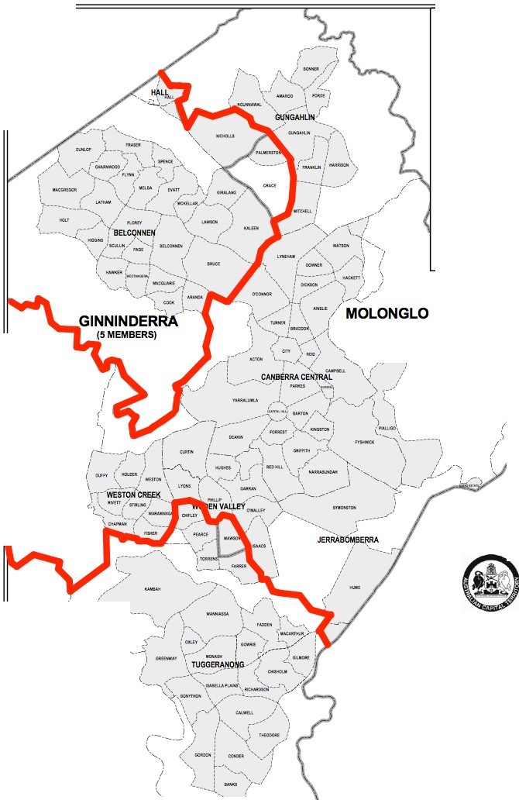

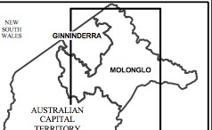

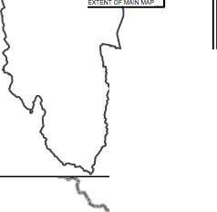

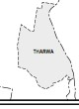

ACT Planning &
Land Authority
Neil Savery Bill Hirst

Augmented ACT Electoral Commission
August 2007

Model g

New Soulh Wales

SRINDABEU.A

l\.'!'11.'
"W"A "JS''

(7 MEMBERS)

MAJURA

KOWEN

STROMLO

New South Wales

BRINDABELLA
(5 MEMBERS)

PADDYS RIVER

0 1 2 3 4
Redistribution of the
Australian Capital Territory into electorates pursuant to the Electoral Act 1992

Electorates for the
ACT Legislative Assembly
of BRINDABELLA, GINNINDERRA
and MOLONGLO

Boundaries of Electora1es Division Boundaries District Boundaries

Kilometres

Roger Beale AO

Phillip Green

ChristabelYoung

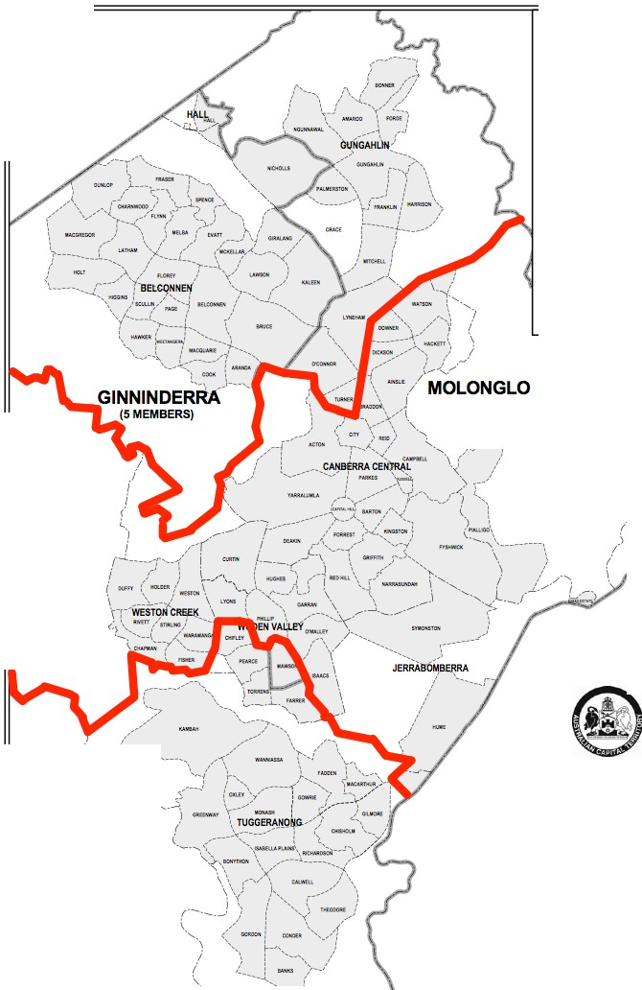

ACT Planning &
Land Authority
Neil Savery Bill Hirst

Augmented ACT Electoral Commission
August 2007

'M.b.d.e.iJ9'

New Soulh Wales

SRINDABEU.A

l\.'!'11.'
"W"A "JS''

(7 MEMBERS)

MAJURA

KOWEN

STROMLO

New South Wales

BRINDABELLA
(5 MEMBERS)

PADDYS RlVER

0 1 2 3 4
Redistribution of the
Australian Capital Territory into electorates pursuant to the Electoral Act 1992

Electorates for the
ACT Legislative Assembly
of BRINDABELLA, GINNINDERRA
and MOLONGLO

Boundaries of Electora1es Division Boundaries District Boundaries

Kilometres

Roger Beale AO

Phillip Green

ChristabelYoung

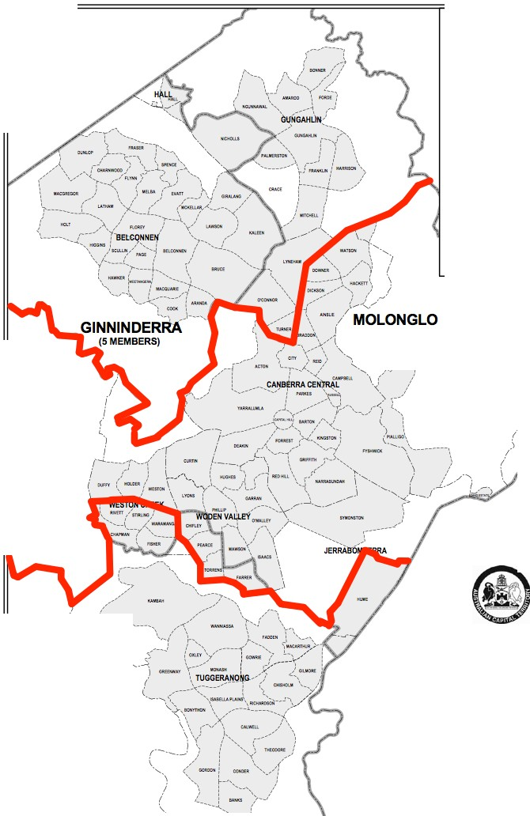

ACT Planning &
Land Authority
Neil Savery Bill Hirst

Augmented ACT Electoral Commission
August 2007

Current and Projected Numbers of Persons Enrolled

Table 1: Australian Capital Territory

Suburb | Actual persons enrolled  30 September 2010 | Projected persons enrolled  20 October 2012 | % change | Present  Electorate
Acton | 360 | 368 | 2.22% | Molonglo
Ainslie | 3864 | 3973 | 2.82% | Molonglo
Amaroo | 3563 | 3688 | 3.51% | Molonglo
Aranda | 1842 | 1836 | -0.33% | Ginninderra
Banks | 3370 | 3951 | 17.24% | Brindabella
Barton | 827 | 928 | 12.21% | Molonglo
Belconnen Town Centre | 2386 | 2843 | 19.15% | Ginninderra
Belconnen - SSD Bal | 32 | 34 | 6.25% | Ginninderra
Bonner | 129 | 523 | 305.43% | Molonglo
Bonython | 2663 | 2831 | 6.31% | Brindabella
Braddon | 2770 | 3157 | 13.97% | Molonglo
Bruce | 3044 | 3659 | 20.20% | Ginninderra
Calwell | 4225 | 4402 | 4.19% | Brindabella
Campbell / Duntroon / Majura | 3923 | 3943 | 0.51% | Molonglo
Casey | 229 | 723 | 215.72% | Molonglo
Chapman | 2201 | 2087 | -5.18% | Molonglo
Charnwood | 2123 | 2052 | -3.34% | Ginninderra
Chifley | 1720 | 1764 | 2.56% | Brindabella
Chisholm | 3873 | 3709 | -4.23% | Brindabella
City | 864 | 1060 | 22.69% | Molonglo
Conder | 3501 | 4084 | 16.65% | Brindabella
Cook | 2181 | 2180 | -0.05% | Ginninderra
Crace | 32 | 112 | 250.00% | Molonglo
Curtin | 3958 | 3975 | 0.43% | Molonglo
Deakin | 2110 | 2127 | 0.81% | Molonglo
Dickson | 1432 | 1482 | 3.49% | Molonglo
Downer | 2468 | 2498 | 1.22% | Molonglo
Duffy | 2390 | 2260 | -5.44% | Molonglo
Dunlop | 4450 | 5218 | 17.26% | Ginninderra
Evatt | 4058 | 3865 | -4.76% | Ginninderra
Fadden | 2489 | 2323 | -6.67% | Brindabella
Farrer | 2579 | 2489 | -3.49% | Brindabella
Fisher | 2355 | 2314 | -1.74% | Molonglo
Florey | 3606 | 3656 | 1.39% | Ginninderra
Flynn | 2624 | 2458 | -6.33% | Ginninderra
Forde | 633 | 862 | 36.18% | Molonglo
Forrest | 1142 | 1156 | 1.23% | Molonglo
Franklin | 1189 | 2961 | 149.03% | Molonglo
Fraser | 1637 | 1541 | -5.86% | Ginninderra
Fyshwick | 24 | 21 | -12.50% | Molonglo
Garran | 2317 | 2342 | 1.08% | Molonglo
Gilmore | 2004 | 1964 | -2.00% | Brindabella
Giralang | 2594 | 2425 | -6.52% | Ginninderra
Gordon | 5450 | 6193 | 13.63% | Brindabella
Gowrie | 2482 | 2371 | -4.47% | Brindabella
Greenway | 1088 | 1199 | 10.20% | Brindabella
Griffith | 3172 | 3306 | 4.22% | Molonglo
Gungahlin | 3120 | 3513 | 12.60% | Molonglo
Gungahlin-Hall - SSD Bal | 16 | 16 | 0.00% | Molonglo
Hackett | 2265 | 2299 | 1.50% | Molonglo
Hall | 235 | 228 | -2.98% | Ginninderra
Harman | 41 | 38 | -7.32% | Molonglo
Harrison | 2462 | 2790 | 13.32% | Molonglo
Hawker | 2199 | 2102 | -4.41% | Ginninderra
Higgins | 2260 | 2137 | -5.44% | Ginninderra
Holder | 2077 | 1978 | -4.77% | Molonglo
Holt | 3506 | 3602 | 2.74% | Ginninderra
Hughes | 2163 | 2196 | 1.53% | Molonglo
Hume | 7 | 7 | 0.00% | Molonglo
Isaacs | 1903 | 1948 | 2.36% | Molonglo
Isabella Plains | 2988 | 3008 | 0.67% | Brindabella
Jerrabomberra | 8 | 9 | 0.00% | Molonglo
Kaleen | 5701 | 5330 | -6.51% | Ginninderra
Kambah | 11752 | 11101 | -5.54% | Brindabella
Kingston | 2179 | 2368 | 8.67% | Molonglo
Kowen | 25 | 26 | 4.00% | Molonglo
Latham | 2775 | 2630 | -5.23% | Ginninderra
Lyneham | 3340 | 3451 | 3.32% | Molonglo
Lyons | 1831 | 1873 | 2.29% | Molonglo
McKellar | 2131 | 2161 | 1.41% | Ginninderra
Macarthur | 1161 | 1184 | 1.98% | Brindabella
Macgregor | 3346 | 4088 | 22.18% | Ginninderra
Macquarie | 1794 | 1819 | 1.39% | Ginninderra
Mawson | 2192 | 2205 | 0.59% | Molonglo
Melba | 2464 | 2448 | -0.65% | Ginninderra
Mitchell | 8 | 8 | 0.00% | Molonglo
Monash | 4205 | 4369 | 3.90% | Brindabella
Narrabundah | 4199 | 4298 | 2.36% | Molonglo
Ngunnawal | 6008 | 6187 | 2.98% | Molonglo
Nicholls | 4990 | 5151 | 3.23% | Ginninderra
Oaks Estate | 192 | 174 | -9.38% | Molonglo
O`Connor | 3833 | 3942 | 2.84% | Molonglo
O`Malley | 664 | 685 | 3.16% | Molonglo
Oxley | 1311 | 1309 | -0.15% | Brindabella
Page | 2009 | 2014 | 0.25% | Ginninderra
Palmerston | 3887 | 4212 | 8.36% | Molonglo
Parkes | 3 | 3 | 0.00% | Molonglo
Pearce | 1917 | 1925 | 0.42% | Brindabella
Phillip | 1333 | 1558 | 16.88% | Molonglo
Pialligo | 95 | 95 | 0.00% | Molonglo
Red Hill | 2316 | 2340 | 1.04% | Molonglo
Reid | 1107 | 1139 | 2.89% | Molonglo
Richardson | 2272 | 2166 | -4.67% | Brindabella
Rivett | 2370 | 2383 | 0.55% | Molonglo
Russell | 0 | 0 | 0.00% | Molonglo
Scullin | 1982 | 1859 | -6.21% | Ginninderra
Spence | 1937 | 1836 | -5.21% | Ginninderra
Stirling | 1496 | 1433 | -4.21% | Molonglo
Stromlo | 6 | 5 | -16.67% | Molonglo
Symonston | 332 | 333 | 0.30% | Molonglo
Theodore | 2740 | 2898 | 5.77% | Brindabella
Torrens | 1694 | 1677 | -1.00% | Brindabella
Tuggeranong - SSD Bal | 26 | 22 | -15.38% | Brindabella
Turner | 2461 | 2535 | 3.01% | Molonglo
Wanniassa | 5950 | 5591 | -6.03% | Brindabella
Waramanga | 1942 | 1825 | -6.02% | Molonglo
Watson | 3629 | 3733 | 2.87% | Molonglo
Weetangera | 1994 | 1926 | -3.41% | Ginninderra
Weston | 2444 | 2416 | -1.15% | Molonglo
Weston Creek-Stromlo - SSD Bal | 30 | 26 | -13.33% | Molonglo
Yarralumla | 2402 | 2440 | 1.58% | Molonglo
Remainder of ACT | 217 | 187 | -13.82% | Brindabella
Total | 247915 | 256168 | 3.33%

Model 1 - MINIMAL CHANGE

Actual Projected Actual Projected Actual Projected Original
Molonglo Molonglo Ginninderra Ginninderra Brindabella Brindabella March 2010 (7 Member) (7 Member) (5 Member) (5 Member) (5 Member) (5 Member) Electorate
360 368 Molonglo
3864 3973 Molonglo
3563 3688 Molonglo
1842 1836 Ginninderra
3370 3951 Brindabella
827 928 Molonglo
2386 2843 Ginninderra
32 34 Ginninderra
129 523 Molonglo
2663 2831 Brindabella
2770 3157 Molonglo
3044 3659 Ginninderra
4225 4402 Brindabella
3923 3943 Molonglo
229 723 Molonglo
2201 2087 Molonglo
2123 2052 Ginninderra
1720 1764 Brindabella
3873 3709 Brindabella
864 1060 Molonglo
3501 4084 Brindabella
2181 2180 Ginninderra
32 112 Molonglo
3958 3975 Molonglo
2110 2127 Molonglo
1432 1482 Molonglo
2468 2498 Molonglo
2390 2260 Molonglo
4450 5218 Ginninderra
4058 3865 Ginninderra
2489 2323 Brindabella
2579 2489 Brindabella
2355 2314 Molonglo
3606 3656 Ginninderra
2624 2458 Ginninderra
633 862 Molonglo
1142 1156 Molonglo
1189 2961 Molonglo
1637 1541 Ginninderra
24 21 Molonglo
2317 2342 Molonglo
2004 1964 Brindabella
2594 2425 Ginninderra
5450 6193 Brindabella
2482 2371 Brindabella
1088 1199 Brindabella
3172 3306 Molonglo
3120 3513 Molonglo
16 16 Molonglo
2265 2299 Molonglo
235 228 Ginninderra
41 38 Molonglo
2462 2790 Molonglo
2199 2102 Ginninderra
2260 2137 Ginninderra
2077 1978 Molonglo
3506 3602 Ginninderra
2163 2196 Molonglo
7 7 Molonglo
1903 1948 Molonglo
2988 3008 Brindabella
8 9 Molonglo
5701 5330 Ginninderra
11752 11101 Brindabella
2179 2368 Molonglo
25 26 Molonglo
2775 2630 Ginninderra
3340 3451 Molonglo
1831 1873 Molonglo
2131 2161 Ginninderra
1161 1184 Brindabella
3346 4088 Ginninderra
1794 1819 Ginninderra
2192 2205 Molonglo
2464 2448 Ginninderra
8 8 Molonglo
4205 4369 Brindabella
4199 4298 Molonglo
6008 6187 Molonglo
4990 5151 Ginninderra
192 174 Molonglo
3833 3942 Molonglo
664 685 Molonglo
1311 1309 Brindabella
2009 2014 Ginninderra
3887 4212 Molonglo
3 3 Molonglo
1917 1925 Brindabella
1333 1558 Molonglo
95 95 Molonglo
2316 2340 Molonglo
1107 1139 Molonglo
2272 2166 Brindabella
2370 2383 Molonglo
0 0 Molonglo
1982 1859 Ginninderra
1937 1836 Ginninderra
1496 1433 Molonglo
6 5 Molonglo
332 333 Molonglo
2740 2898 Brindabella
1694 1677 Brindabella
26 22 Brindabella
2461 2535 Molonglo
5950 5591 Brindabella
1942 1825 Molonglo
3629 3733 Molonglo
1994 1926 Ginninderra
2444 2416 Molonglo
30 26 Molonglo
2402 2440 Molonglo
217 187 Brindabella
TOTAL 100227 105824 73819 75422 73869 74922

QUOTA 102082 105480 72916 75343 72916 75343
Variance 1855 -344 -903 -79 -953 421
%age of quota 1.82% -0.33% -1.24% -0.10% -1.31% 0.56%

Complies

Complies

ensure that the number of electors in an electorate immediately after the redistribution is within the range of not greater than 110%, or less than 90% of the quota;
endeavour to ensure, as far as practicable, that the number of electors in an electorate at the time of the next general election of members of the Legislative Assembly will not be greater than 105%, or less than 95%, of the expected quota for the electorate at that time;

duly consider

MODEL 2 - Northern, Central and Southern Electorates (Molonglo Adjustments)

New ActualNew Projected New ActualNew Projected Actual Projected Original
Molonglo Molonglo Ginninderra Ginninderra Brindabella Brindabella March 2010 (5 Member) (5 Member) (7 Member) (7 Member) (5 Member) (5 Member) Electorate
360 368 Molonglo
3864 3973 Molonglo
3563 3688 Molonglo
1842 1836 Ginninderra
3370 3951 Brindabella
827 928 Molonglo
2386 2843 Ginninderra
32 34 Ginninderra
129 523 Molonglo
2663 2831 Brindabella
2770 3157 Molonglo
3044 3659 Ginninderra
4225 4402 Brindabella
3923 3943 Molonglo
229 723 Molonglo
2201 2087 Molonglo
2123 2052 Ginninderra
1720 1764 Brindabella
3873 3709 Brindabella
864 1060 Molonglo
3501 4084 Brindabella
2181 2180 Ginninderra
32 112 Molonglo
3958 3975 Molonglo
2110 2127 Molonglo
1432 1482 Molonglo
2468 2498 Molonglo
2390 2260 Molonglo
4450 5218 Ginninderra
4058 3865 Ginninderra
2489 2323 Brindabella
2579 2489 Brindabella
2355 2314 Molonglo
3606 3656 Ginninderra
2624 2458 Ginninderra
633 862 Molonglo
1142 1156 Molonglo
1189 2961 Molonglo
1637 1541 Ginninderra
24 21 Molonglo
2317 2342 Molonglo
2004 1964 Brindabella
2594 2425 Ginninderra
5450 6193 Brindabella
2482 2371 Brindabella
1088 1199 Brindabella
3172 3306 Molonglo
3120 3513 Molonglo
16 16 Molonglo
2265 2299 Molonglo
235 228 Ginninderra
41 38 Molonglo
2462 2790 Molonglo
2199 2102 Ginninderra
2260 2137 Ginninderra
2077 1978 Molonglo
3506 3602 Ginninderra
2163 2196 Molonglo
7 7 Molonglo
1903 1948 Molonglo
2988 3008 Brindabella
8 9 Molonglo
5701 5330 Ginninderra
11752 11101 Brindabella
2179 2368 Molonglo
25 26 Molonglo
2775 2630 Ginninderra
3340 3451 Molonglo
1831 1873 Molonglo
2131 2161 Ginninderra
1161 1184 Brindabella
3346 4088 Ginninderra
1794 1819 Ginninderra
2192 2205 Molonglo
2464 2448 Ginninderra
8 8 Molonglo
4205 4369 Brindabella
4199 4298 Molonglo
6008 6187 Molonglo
4990 5151 Ginninderra
192 174 Molonglo
3833 3942 Molonglo
664 685 Molonglo
1311 1309 Brindabella
2009 2014 Ginninderra
3887 4212 Molonglo
3 3 Molonglo
1917 1925 Brindabella
1333 1558 Molonglo
95 95 Molonglo
2316 2340 Molonglo
1107 1139 Molonglo
2272 2166 Brindabella
2370 2383 Molonglo
0 0 Molonglo
1982 1859 Ginninderra
1937 1836 Ginninderra
1496 1433 Molonglo
6 5 Molonglo
332 333 Molonglo
2740 2898 Brindabella
1694 1677 Brindabella
26 22 Brindabella
2461 2535 Molonglo
5950 5591 Brindabella
1942 1825 Molonglo
3629 3733 Molonglo
1994 1926 Ginninderra
2444 2416 Molonglo
30 26 Molonglo
2402 2440 Molonglo
217 187 Brindabella
TOTAL 73236 74625 100810 106621 73869 74922

QUOTA 72916 75343 102082 105480 72916 75343
Variance -320 718 1272 -1141 -953 421
%age of quota -0.44% 0.95% 1.25% -1.08% -1.31% 0.56%

Complies

Complies

ensure that the number of electors in an electorate immediately after the redistribution is within the range of not greater than 110%, or less than 90% of the quota;
endeavour to ensure, as far as practicable, that the number of electors in an electorate at the time of the next general election of members of the Legislative Assembly will not be greater than 105%, or less than 95%, of the expected quota for the electorate at that time;

MODEL 3 - Northern, Central and Southern Electorates (Molonglo & Brindabella Adjustments)

New ActualNew Projected New ActualNew Projected Actual Projected Original
Molonglo Molonglo Ginninderra Ginninderra Brindabella Brindabella March 2010 (5 Member) (5 Member) (7 Member) (7 Member) (5 Member) (5 Member) Electorate
360 368 Molonglo
3864 3973 Molonglo
3563 3688 Molonglo
1842 1836 Ginninderra
3370 3951 Brindabella
827 928 Molonglo
2386 2843 Ginninderra
32 34 Ginninderra
129 523 Molonglo
2663 2831 Brindabella
2770 3157 Molonglo
3044 3659 Ginninderra
4225 4402 Brindabella
3923 3943 Molonglo
229 723 Molonglo
2201 2087 Molonglo
2123 2052 Ginninderra
1720 1764 Brindabella
3873 3709 Brindabella
864 1060 Molonglo
3501 4084 Brindabella
2181 2180 Ginninderra
32 112 Molonglo
3958 3975 Molonglo
2110 2127 Molonglo
1432 1482 Molonglo
2468 2498 Molonglo
2390 2260 Molonglo
4450 5218 Ginninderra
4058 3865 Ginninderra
2489 2323 Brindabella
2579 2489 Brindabella
2355 2314 Molonglo
3606 3656 Ginninderra
2624 2458 Ginninderra
633 862 Molonglo
1142 1156 Molonglo
1189 2961 Molonglo
1637 1541 Ginninderra
24 21 Molonglo
2317 2342 Molonglo
2004 1964 Brindabella
2594 2425 Ginninderra
5450 6193 Brindabella
2482 2371 Brindabella
1088 1199 Brindabella
3172 3306 Molonglo
3120 3513 Molonglo
16 16 Molonglo
2265 2299 Molonglo
235 228 Ginninderra
41 38 Molonglo
2462 2790 Molonglo
2199 2102 Ginninderra
2260 2137 Ginninderra
2077 1978 Molonglo
3506 3602 Ginninderra
2163 2196 Molonglo
7 7 Molonglo
1903 1948 Molonglo
2988 3008 Brindabella
8 9 Molonglo
5701 5330 Ginninderra
11752 11101 Brindabella
2179 2368 Molonglo
25 26 Molonglo
2775 2630 Ginninderra
3340 3451 Molonglo
1831 1873 Molonglo
2131 2161 Ginninderra
1161 1184 Brindabella
3346 4088 Ginninderra
1794 1819 Ginninderra
2192 2205 Molonglo
2464 2448 Ginninderra
8 8 Molonglo
4205 4369 Brindabella
4199 4298 Molonglo
6008 6187 Molonglo
4990 5151 Ginninderra
192 174 Molonglo
3833 3942 Molonglo
664 685 Molonglo
1311 1309 Brindabella
2009 2014 Ginninderra
3887 4212 Molonglo
3 3 Molonglo
1917 1925 Brindabella
1333 1558 Molonglo
95 95 Molonglo
2316 2340 Molonglo
1107 1139 Molonglo
2272 2166 Brindabella
2370 2383 Molonglo
0 0 Molonglo
1982 1859 Ginninderra
1937 1836 Ginninderra
1496 1433 Molonglo
6 5 Molonglo
332 333 Molonglo
2740 2898 Brindabella
1694 1677 Brindabella
26 22 Brindabella
2461 2535 Molonglo
5950 5591 Brindabella
1942 1825 Molonglo
3629 3733 Molonglo
1994 1926 Ginninderra
2444 2416 Molonglo
30 26 Molonglo
2402 2440 Molonglo
217 187 Brindabella
TOTAL 72967 74636 100810 106621 74138 74911

QUOTA 72916 75343 102082 105480 72916 75343
Variance -51 707 1272 -1141 -1222 432
%age of quota -0.07% 0.94% 1.25% -1.08% -1.68% 0.57%

Complies

Complies

ensure that the number of electors in an electorate immediately after the redistribution is within the range of not greater than 110%, or less than 90% of the quota;
endeavour to ensure, as far as practicable, that the number of electors in an electorate at the time of the next general election of members of the Legislative Assembly will not be greater than 105%, or less than 95%, of the expected quota for the electorate at that time;

