Dear Mr Green

Following are our suggestions regarding the redistribution of electoral boundaries for the
ACT.

However, we should say at the outset that we feel most of this process will be in vain, and the committee will default to the "least change" approach it did last time around. The problem with that approach of course is that it does not fix the problem in a lasting manner, as evident from the fact that we need more changes just three years later. The incremental approach does not account for the rapid population growth in the north.

And the core problem will remain: the seven-member Molonglo electorate will remain geographically sprawling from almost Tuggeranong, through Weston, Woden, central Canberra and circling around Belconnen through most (but not all) of Gungahlin. There will remain some MLAs representing parts of Gungahlin who know little of the Gungahlin community's issues, and if we are frank seldom set foot in Gungahlin.

Our preferred approach is for the ACT to have additional MLAs. As we explained during the last redistribution, it is evident to us that the workloads involved with a 17-member Assembly are unacceptable, leading to inadequate decisionmaking that may not have occurred if there was better oversight and issue knowledge by ministers with less demanding portfolios. We note that not one Government MLA has attended a single GCC meeting since the last
election, and rare conversations our representatives have had with them at functions etc make it clear that some are falling out of touch with the community they represent. It has also been argued that some of the problem stems from lack of depth within the Government "back bench". Similar arguments can be put forward regarding the quality of opposition resulting from the small Assembly depth.

We have attempted to stimulate public debate on the issue of Assembly size, but have been disappointed by the lack of support or even interest from many incumbent MLAs. We would have thought that if there was one issue for which they could put aside grandstanding in favour of a united approach to the Federal Government supporting a better solution for the people of the ACT, then this would be it. It seems not.

As can be seen from the attached output from our electorate modelling software, five electorates of five MLAs each with quotas of approximately 10,000 electors can be easily achieved. These electorates can align closely to established communities of interest: Belconnen, North Canberra/Gungahlin, Central Canberra, Weston/Woden, and Tuggeranong. Each possible electorate is geographically constrained, which would give elected members
far better opportunity to closely engage with the community they represent.

However, as previously stated, it seems the parliament hasn't the mood to pursue such an improvement, so we will be stuck with a 7-5-5 Assembly, with a quota of about 15,000 electors - an increase of 1000 per MLA from the current term. Given that unfortunate situation, we have sought a solution that aligns communities of interest as closely as possible, while preserving a small negative variance where the growth will be greatest over the next eight years - Gungahlin, hopefully minimising the need for another redistribution next term.

The attached output shows a five-member electorate covering Tuggeranong and Weston
(nominally Brindabella), and a second five-member electorate with all of Woden and the

Inner South, plus the Inner North (Molonglo).

The seven-member Ginninderra electorate would entirely encompass Belconnen and Gungahlin - areas with many common issues, characteristics and challenges. Watson from north Canberra would make up the numbers, recognising that this suburb is heavily used by Gungahlin people, who frequent its schools, childcare centres and shops. The electorate would be five per cent under variance initially, well under the 10 per cent requirement. This would absorb significant Gungahlin population growth without the need for redistribution. Further out, and assuming still no solution for increasing the Assembly size, Gungahlin will grow to the extent that Watson could be moved from Ginninderra to Molonglo.

Similarly, this solution has Molonglo with a 1.6 per cent negative variance, sufficient to absorb population growth in the new suburbs of Molonglo. Brindabella electorate would start the term with a 7.6 per cent over variance, also under the 10 per cent requirement, and sufficient to buffer the population expansion in the other electorates, most likely for more than one term.

A similar alternative would have Brindabella as a five-member electorate covering Tuggeranong and up to Hindmarsh Drive, and Molonglo from Woden and Weston, through the Inner South and Inner North, but with the two suburbs of Lyneham and Watson incorporated into Ginninderra. The variances for this option are smaller though, and would therefore be less resilient against likely population growth.

We would be pleased to further explain our proposals. Regards,
Alan Kerlin
Gungahlin Community Council
Spokesman - Planning, Transport and Environment m 0408 771633

10 March 2011

Title: ACT Electoral Boundary Modelling Tool Status: GCC Release (Unlocked Suburb & Elector Data) Version: 02 - 070214
Brindabella | B | 81,584 | 31.85%
Ginninderra | G | 100,426 | 39.20%
Molonglo | M | 74,158 | 28.95%
Alpha | A
Charlie | C
Delta | D
Echo | E
Foxtrot | F
Indigo | I
Juliet | J
Unallocated

Brindabella | B | 5.414 | 5 | 7.65%
Ginninderra | G | 6.665 | 7 | -5.03%
Molonglo | M | 4.921 | 5 | -1.60%
Alpha | A
Charlie | C
Delta | D
Echo | E
Foxtrot | F
Indigo | I
Juliet | J
Unallocated

Copyright © 2002-2007 - Jonathon Reynolds (Original Design Concept)
© 2002-2007 - Antti Roppola (GIS Coding Components)

Only cells marked in GREEN can be changed.
TOTAL 256,168 100.0% TOTAL 17.000 17 Map cells must contain a valid electorate code
Quota Rounding Error - use the pull down option box in these cells

Unmapped Components Taylor Bonner
G Moncrieff G
Remainder Kinlyside G B G

Pierces Creek Casey
B G Forde Throsby
Hall Amaroo G G
Corin Dam G G B Ngunnawal
G

Nicholls Gungahlin
G G

Fraser
Dunlop G
G Palmerston Mulanggari
Spence G G G Harrison
Charnwood G
G Franklin
G
Flynn Crace Kenny
G Melba G G

Macgregor G Evatt
Giralang

G G G

Latham McKellar
G G

Holt Mitchell
G Florey Lawson G G G Kaleen
G
Higgins Scullin
G G Watson
G
Page
G Belconnen Lyneham
G M
Bruce Downer
Hawker G M G Weetangera
G Macquarie Hackett
G Dickson M
M Majura
O'Connor M
Aranda M
Cook G Ainslie
G M

Acton
M
Turner
M

City
M

Braddon
M

Reid
M Pialligo
M

Campbell/Duntroon
M

Parkes
M
Russell
M

Stromlo

Yarralumla
M

Barton Fairbairn Kowen Forest
M M M

M Kingston Fyshwick
Forrest M M M
Deakin
Curtin M
M Griffith
Mount Stromlo Weston Ck M
Cotter Dam M B Red Hill
B M Oaks Estate
Duffy Hughes M B Holder M Narrabundah
B M
HMAS Harman
Lyons M
Weston M Garran
B M
Rivett Phillip
B Stirling M Symonston
B Swinger Hill O'Malley M
Waramanga Chifley M M B M

Chapman
B Jerrabomberra
Fisher Pearce Mawson M B M M

Torrens
M

Farrer
M

Isaacs
M

Hume
M

Kambah
B

Wanniassa
B

Fadden

Greenway B
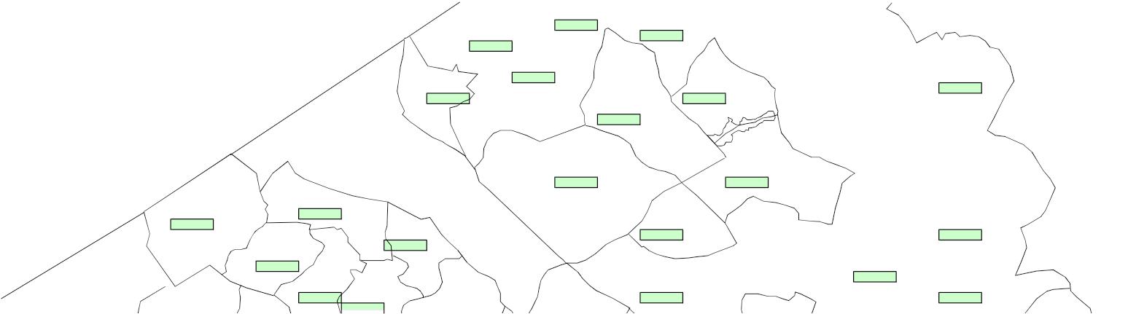

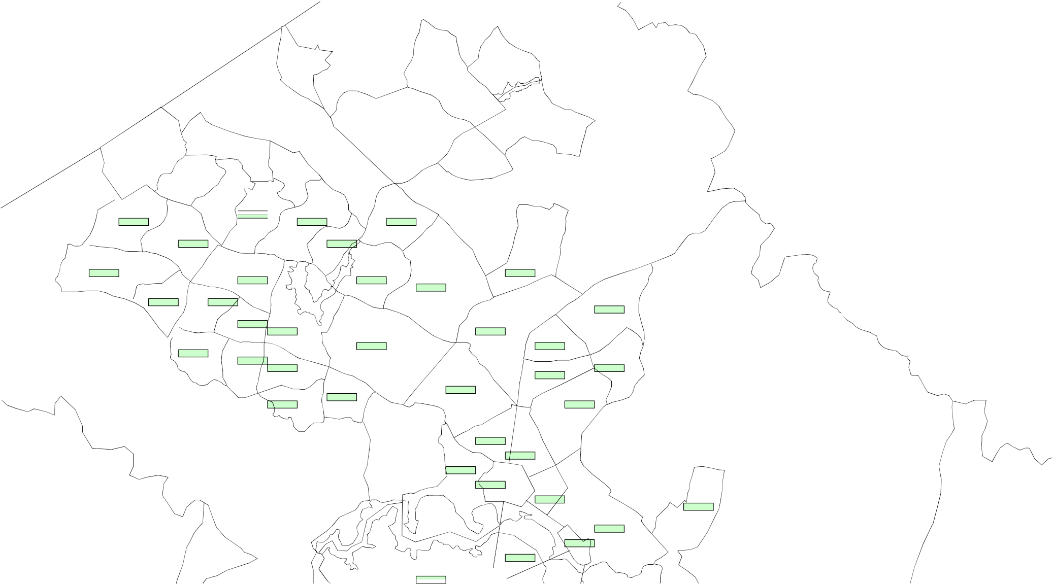

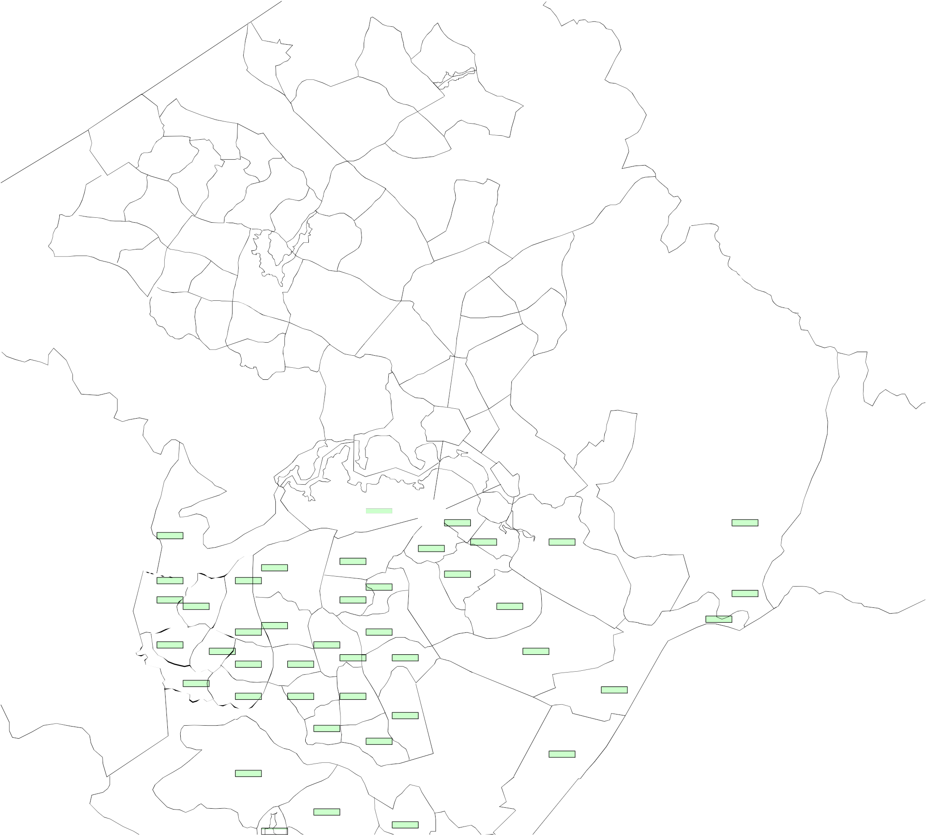

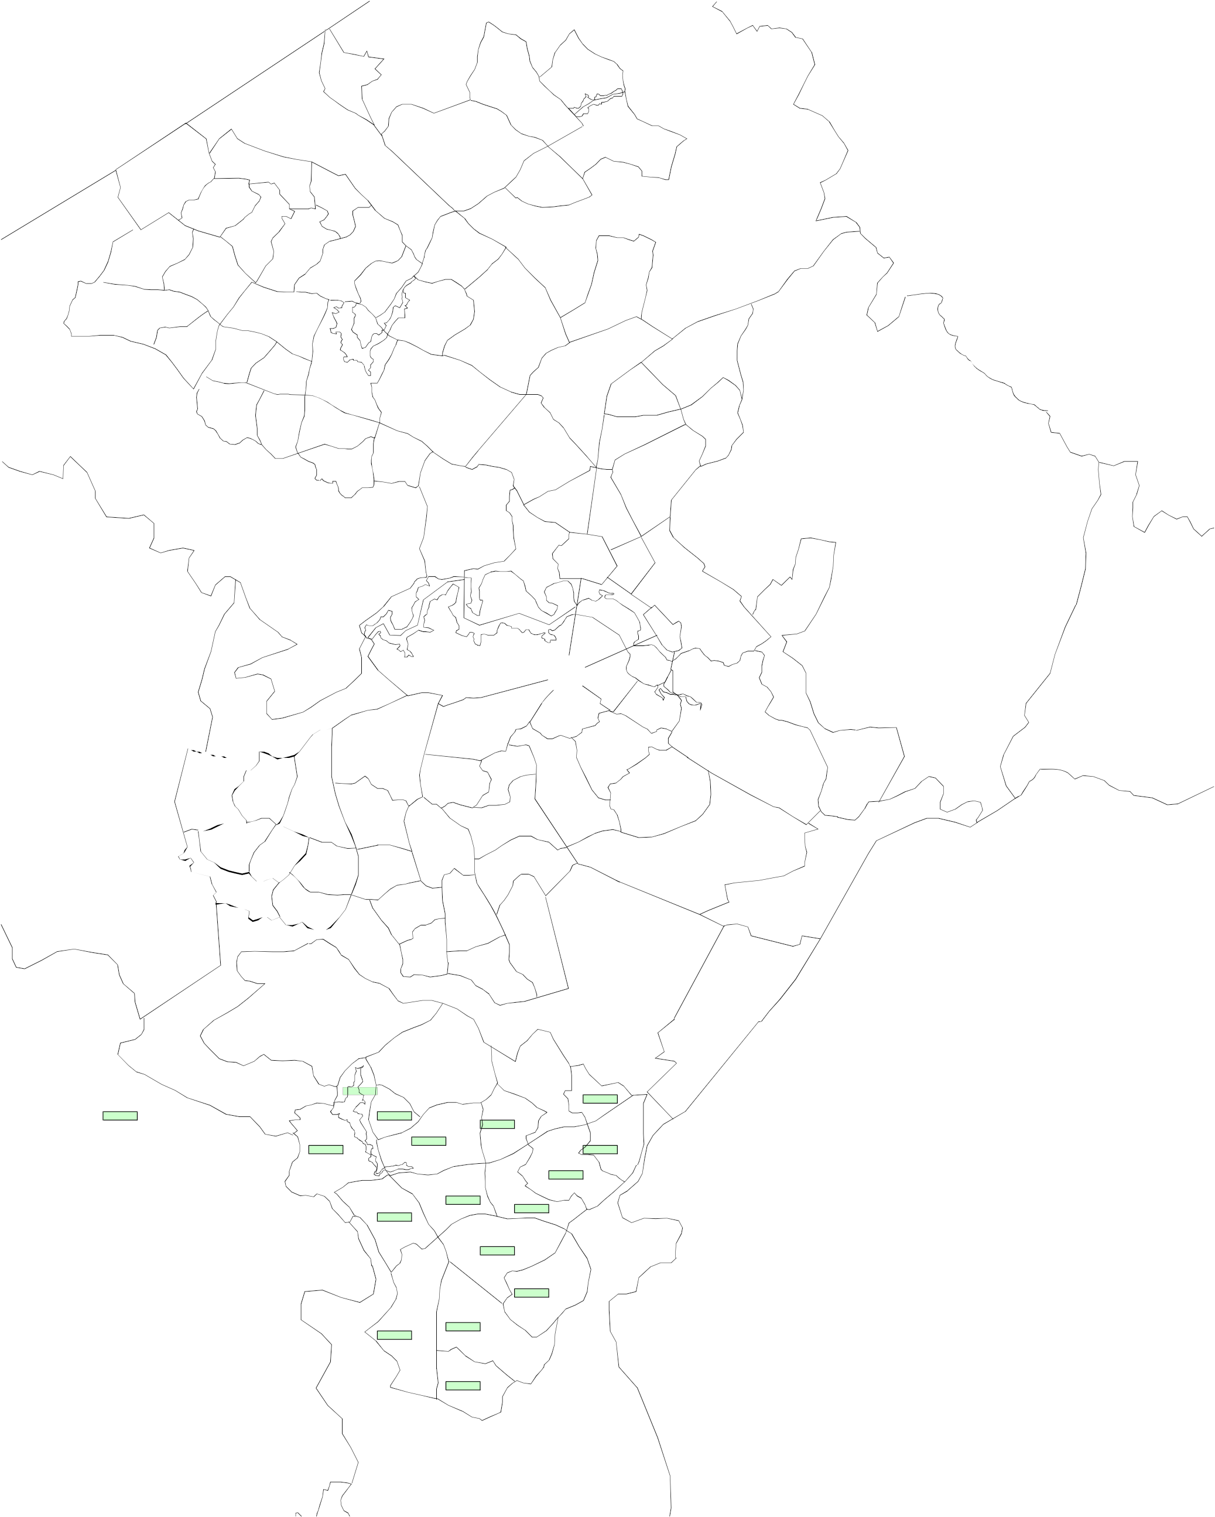

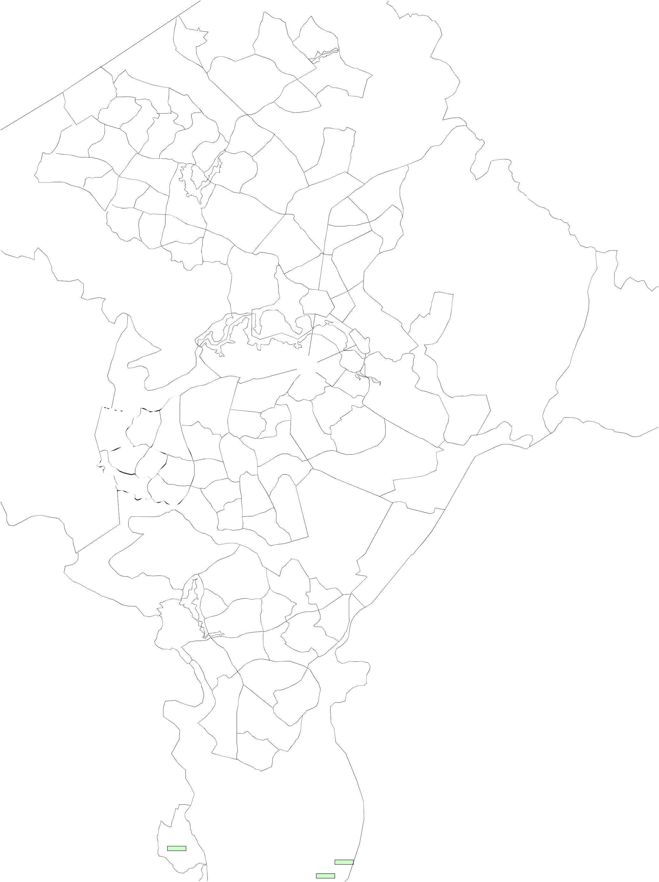



B Macarthur
B
B
Uriarra Oxley
B B Gowrie
B
Monash
Tuggeranong B Gilmore
B B

Chisholm
B

Isabella Plains
B Richardson
Bonython B B

Calwell
B

Theodore
B

Conder
Gordon B B

Banks
B

Tharwa
B

Royalla
B

Williamsdale
B

Title: ACT Electoral Boundary Modelling Tool Status: GCC Release (Unlocked Suburb & Elector Data) Version: 02 - 070214
Brindabella | B | 48,170 | 18.80%
Ginninderra | G | 52,469 | 20.48%
Molonglo | M | 52,547 | 20.51%
NC/Gung | A | 50187 | 19.59%
Woden | C | 52272 | 20.41%
Delta | D
Echo | E
Foxtrot | F
Indigo | I
Juliet | J
Unallocated |  | 523 | 0.20%

Brindabella | B | 4.701 | 5 | -6.36%
Ginninderra | G | 5.121 | 5 | 2.35%
Molonglo | M | 5.128 | 5 | 2.50%
NC/Gung | A | 4.898 | 5 | -2.09%
Woden | C | 5.101 | 5 | 1.99%
Delta | D
Echo | E
Foxtrot | F
Indigo | I
Juliet | J
Unallocated |  | 0.051 |  | 100.00%

Copyright © 2002-2007 - Jonathon Reynolds (Original Design Concept)
© 2002-2007 - Antti Roppola (GIS Coding Components)

Only cells marked in GREEN can be changed.
TOTAL 256,168 100.0% TOTAL 25.000 25 Map cells must contain a valid electorate code
Quota Rounding Error - use the pull down option box in these cells

Unmapped Components Taylor Bonner
A Moncrieff
Remainder Kinlyside A B A

Pierces Creek Casey
B A Forde Throsby
Hall Amaroo A
Corin Dam A A B Ngunnawal
A

Nicholls Gungahlin
A A

Fraser
Dunlop G
G Palmerston Mulanggari
Spence A
G Harrison
Charnwood A
G Franklin
A
Flynn Crace Kenny
G Melba A

Macgregor G Evatt
Giralang

G G A

Latham McKellar
G G

Holt Mitchell
G Florey Lawson A G A Kaleen
A
Higgins Scullin
G G Watson
A
Page
G Belconnen Lyneham
G A
Bruce Downer
Hawker M A G Weetangera
G Macquarie Hackett
G Dickson A
M Majura
O'Connor A
Aranda M
Cook M Ainslie
G M

Acton
M
Turner
M

City
M

Braddon
M

Reid
M Pialligo
M

Campbell/Duntroon
M

Parkes
M
Russell
M

Stromlo

Yarralumla
M

Barton Fairbairn Kowen Forest
M M M

C Kingston Fyshwick
Forrest M M M
Deakin
Curtin M
M Griffith
Mount Stromlo Weston Ck M
Cotter Dam C C Red Hill
C M Oaks Estate
Duffy Hughes M C Holder M Narrabundah
C M
HMAS Harman
Lyons C
Weston C Garran
C C
Rivett Phillip
C Stirling C Symonston
C Swinger Hill O'Malley C
Waramanga Chifley C C C C

Chapman
C Jerrabomberra
Fisher Pearce Mawson C C C C

Torrens
C

Farrer
C

Isaacs
C

Hume
C

Kambah
C

Wanniassa
C

Fadden

Greenway B

B Macarthur
B
B
Uriarra Oxley
C B Gowrie
B
Monash
Tuggeranong B Gilmore
B B

Chisholm
B

Isabella Plains
B Richardson
Bonython B B

Calwell
B

Theodore
B

Conder
Gordon B B

Banks
B

Tharwa
B

Royalla
B

Williamsdale
B

